PROBLEM STATEMENT
In the previous years, informal online communities like Face book and YouTube have become progressively common platform in an individual person’s day to day life. People use social media as a virtual community platform to stay in touch with friends and family and to also share thoughts and ideas in blogs.
OBJECTIVE:
Due to this developing pattern, these platforms pull in an enormous number of clients and are easy targets for spammers. YouTube has become the most well-known informal community among youngsters. For example, many makeup tutorials have been started by bloggers who are referred to as “beauty guru” or “beauty influencers” in which majority of the audiences are teenage girls. These days, 200 million clients produce 400 million new YouTube content (videos) every day
ABSTRACT:
With the raised quality of online social networks, spammers realize these platforms are simple to lure users into malicious activities by posting spam messages in the comments section of the videos. In this work, YouTube comments have been taken and spam detection is performed. To stop spammers, Google Safe Browsing and YouTube Bookmaker tools detect and block spam YouTube. These tools will block malicious links, however they cannot protect the user in real-time as early as possible. Thus, industries and researchers have applied completely different approaches to form spam free social network platform. The survey for the spam comments detection methodology has been carried out using four Artificial Intelligence estimations – Logistic Regression, Ada Boost, Decision Tree and Random Forest. With the use of Neural Network, we can achieve an exactness of 91.65% and beat the present course of action by around 18%. The most notable AI procedures (Bayesian portrayal, k-NN, ANNs, SVMs) and of their suitability to the issue of spam.

INTRODUCTION
In the previous years, informal online communities like Face book and YouTube have become progressively common platform in an individual person’s day to day life. People use social media as a virtual community platform to stay in touch with friends and family and to also share thoughts and ideas in blogs. Due to this developing pattern, these platforms pull in an enormous number of clients and are easy targets for spammers. YouTube has become the most well-known informal community among youngsters. For example, many makeup tutorials have been started by bloggers who are referred to as “beauty guru” or “beauty influencers” in which majority of the audiences are teenage girls. These days, 200 million clients produce 400 million new YouTube content (videos) every day. This extensive environment provided by YouTube also creates an opportunity for spammers to create irrelevant content directed to users. These irrelevant or unsolicited messages are aimed to attack users by luring them into clicking links to view malicious sites containing malware, phising and scams. One of the most highlighted features of YouTube is the comments section below every video posted by a user. This feature allows users to share opinions and ideas. In this project, the prediction of the spam comments present in the comments section of Youtube videos using the concept called machine learning, it is also known as subset of artificial intelligence, is done. Supervised learning approach depends on a very large number of labelled datasets. . The proposed classification algorithm (Logistic Regression) is used in order to predict the spam comment. The purpose of project is to introduce briefly the techniques of machine learning and to outline the prediction technique. Being much more superior to the conventional data analysis techniques, machine learning can open a new opportunity to explore and increase the prediction accuracy. Spam remarks are regularly completely immaterial to the given video and are normally created via mechanized bots camouflaged as a client. The comments section is target by spammers to post completely irrelevant messages, comments, links and ideas. AI is the strategy for extraction, changing, stacking and anticipating the significant data from enormous information to remove a few examples and furthermore change it into justifiable structure for additional utilization. Grouping and expectation are two sorts of dissecting information which portray principal classes of information and forecast of patterns in future information. The noxious spam remarks will ruin the positive perspective of the contents present in the videos posted. The contingency for anticipating the spam remarks has started but has yet not been concluded and built up for an exact forecast of spam remarks.
LITERATURE REVIEW
AN EFFICIENT MODULARITY BASED ALGORITHM FOR COMMUNITY DETECTION IN SOCIAL NETWORK, IEEE. Network identification process expects to recognize bunches in an interpersonal organization (SN), where hubs inside the group are thickly associated when contrasted with hubs outside the group. This procedure is one of the difficult issues in time of large information examination especially in the region of long range interpersonal communication. Diagram information structure is frequently used to speak to SN, where hubs can be utilized to speak to on-screen characters and edges can be utilized to speak to connections among the entertainers. There are a few calculations for network identification reason in a SN yet everyone has certain disadvantages in identifying network over a huge scope arrange. A proficient measured quality based network discovery calculation has been proposed in this work. The proposed calculation has been contrasted and other existing network identification calculations utilizing the absolute most famous informal organization datasets. Execution of the calculation has been surveyed utilizing different parameters like particularity, bunching coefficient, execution time and so on.
A SCALABLE DISTRIBUTED LOUVAIN ALGORITHM FOR LARGESCALE GRAPH COMMUNITY DETECTION. We present another circulated network discovery calculation for enormous diagrams dependent on the Louvain strategy. We abuse a conveyed delegate apportioning to guarantee the outstanding task at hand and correspondence adjusting among processors. Furthermore, we plan another heuristic technique to deliberately facilitate the network constitution in an appropriated domain, and guarantee the union of the circulated bunching calculation. Our escalated test study has exhibited the adaptability and the rightness of our calculation with engineered chart datasets
Maintaining “What Videos Are Similar with You? Learning a Common Attributed Representation for Video Recommendation.” In any case, it is as yet testing to adjust the jobs of social qualities and substance characteristics, learn such a typical portrayal in inadequate client video communications and manage the chilly beginning issue. Right now, propose a regularized Dual-factor Regression (REDAR) technique dependent on lattice factorization. Right now, traits and substance qualities are deftly joined, and social and substance data are adequately misused to ease the sparsity issue. A gradual variant of REDAR is intended to take care of the cool beginning issue. We widely assess the proposed strategy for video suggestion application in genuine interpersonal organization dataset, and the outcomes show that, much of the time, the proposed technique can accomplish a general improvement of over 20% contrasted with best in class pattern strategies.
“PARALLEL HEURISTICS FOR SCALABLE COMMUNITY DETECTION. “ Network location has become an essential activity in various diagram” theoretic applications. It is utilized to uncover normal divisions that exist” inside genuine systems without forcing earlier size or cardinality requirements on the arrangement of networks. In spite of its potential for application, there is just constrained help for network identification for enormous scope equal PCs, to a great extent inferable from the unpredictable and naturally successive nature of the fundamental heuristics. Right now, present parallelization heuristics for quick network location “utilizing the Louvain strategy as the sequential layout. The Louvain strategy is a multi-stage, iterative heuristic for” measured quality enhancement. Initially created by Blondel et al. (2008), the technique has become progressively well known inferable from its capacity to identify high particularity network segments in a quick and memoryproficient way. Appeared differently in relation to the consecutive louvain use our equivalent execution can make organize yields with a higher estimated quality for most by far of the data.
SOURCE PERSONALITY AND PERSUASIVENESS: BIG FIVE PREDISPOSITIONS TO BEING PERSUASIVE AND THE ROLE OF MESSAGE INVOLVEMENT. Twitter, the most famous web based life stages, gives a helpful method to individuals to impart what's more, speak with each other. It has been all around perceived that impact exists during clients' cooperations. Some pioneer concentrates on finding powerful clients have been accounted for in the writing, yet they don't recognize diverse impact jobs, which are of extraordinary incentive for different promoting purposes. Right now, push a stride ahead attempting to additionally recognize impact jobs of Twitter clients in a specific theme. By characterizing three perspectives on highlights identifying with subject, feeling and prominence individually, they propose a Multi-see Influence Role Clustering (MIRC) calculation to gather Twitter clients into five classifications. Test results show the adequacy of the proposed approach in construing impact jobs
IN “P. CHOPADE, J. ZHAN, AND M. BIKDASH. NODE ATTRIBUTES AND EDGE STRUCTURE FOR LARGE-SCALE BIG DATA NETWORK ANALYTICS AND COMMUNITY DETECTION. IN INTERNATIONAL SYMPOSIUM ON TECHNOLOGIES FOR HOMELAND SECURITY (HST), PAGES 1–8, 2015” Identifying network communities is one of the most important tasks when analyzing complex networks. Most of these networks possess a certain community structure that has substantial importance in building an understanding regarding the dynamics of the large-scale network. Intriguingly, such communities appear to be connected with unique spectral property of the graph Laplacian of the adjacency matrix and we exploit this connection by using modified relationship between Laplacian and adjacency matrix. We propose modularity optimization based on a greedy agglomerative method, coupled with fast unfolding of communities in large-scale networks using Louvain community finding method. Our proposed modified algorithm is linearly scalable for efficient identification of communities in huge directed/undirected networks. The proposed algorithm shows great performance and scalability on benchmark networks in simulations and successfully recovers communities in real network applications. In this paper, we develop communities from node attributes and edge structure. New modified algorithm statistically models the interaction between the network structure and the node attributes which leads to more accurate community detection as well as helps for identifying robustness of the network structure. We also show that any community must contain a dense ErdosRenyi (ER) subgraph. We carried out comparisons of the Chung and Lu (CL) and Block Two-Level Erdos-Renyi (BTER) models with four real-world data sets. Results demonstrate that it accurately captures the observable properties of many real-world networks. Large-scale network analytics and community detection has been one of the central problems in complex network studies and directed network is particularly challenging due to asymmetry among its links. Community detection algorithms are fundamental tools that allow us to uncover organizational principles in networks. When detecting communities, there are two possible sources of information one can use: the network structure, and the features and attributes of nodes. Even though communities form around nodes that have common edges and common attributes, typically, algorithms have only focused on one of these two data modalities: community detection algorithms traditionally focus only on the network structure, while clustering algorithms mostly consider only node attributes. Community structure is thought to be one of the main organizing principles in most complex networks, including biological, social, and economic systems [1], [2], [3], [4]. Communities or modules are groups of nodes forming tightly connected units that are only weakly linked to each other; they reflect topological relationships between elements of the underlying system and represent functional entities [5], [6]. The identification of these communities is of crucial importance as they may help to uncover a-priori unknown functional modules such as topics in information networks or cyber-communities in social networks. This paper is extension of our previous work [7]. New modified relationship between adjacency and Laplacian matrix along with modelling and analysis aspects are discussed in more details as compared to our previous published work In this work large-scale network analytics is based on structural properties of the network. If a network consists of nodes and edges, then nodes that belong to the same communities are likely to be connected to each other. Communities can overlap, as individual nodes may belong to multiple communities. If two nodes belong to multiple common communities, they are more likely to be connected than if they share only a single common community (i.e., overlapping communities are denser). Nodes in the same community are likely to share common attributes for example; a community might consist of friends attending a same school. Here we consider node degree distribution, algebraic connectivity and clustering coefficient as the parameters which covers node attributes and edge structure.
IN “X. QUE, F. CHECCONI, F. PETRINI, AND J. A. GUNNELS. SCALABLE COMMUNITY DETECTION WITH THE LOUVAIN ALGORITHM. IN PARALLEL AND DISTRIBUTED PROCESSING SYMPOSIUM (IPDPS), PAGES 28–37, 2015” In this paper we present and evaluate a parallel community detection algorithm derived from the state-of-the-art Louvain modularity maximization method. Our algorithm adopts a novel graph mapping and data representation, and relies on an efficient communication runtime, specifically designed for fine-grained applications executed on large-scale supercomputers. We have been able to parallelize graphs with up to 138 billion edges on 8,192 Blue Gene/Q nodes and 1,024 P7-IH nodes. Leveraging the convergence properties of our algorithm and the efficient implementation, we can analyze communities of largescale graphs in just a few seconds. To the best of our knowledge, this is the first parallel implementation of the Louvain algorithm that scales to these large data and processor configurations. Community detection is an important problem that spans many research areas, such as health care, social networks, systems biology, power grid optimization, etc. [1] It is not surprising that it has been so extensively investigated over the last few years. Community detection algorithms attempt to identify the modules and, possibly, their hierarchical organization, in a graph. While there is no rigorous mathematical definition of community structure, the modularity metric proposed by Girvan and Newman [2] is one of the most used and best known functions to quantify community structure in a graph. From an empirical point of view, a high modularity value typically indicates a good quality partition. The techniques used for modularity maximization can be categorized into four main classes: greedy, simulated annealing, extremal, and spectral optimization. Greedy optimization applies different approaches to merge vertices into communities for higher modularity, which normally generates high quality communities [3]. Simulated annealing adopts a probabilistic procedure for global optimization on modularity [4].Extremal optimization is a heuristic search procedure [5]. Spectral optimization uses the eigenvalues and eigenvectors of a special matrix for modularity optimization [6]. These methods normally lead to poor results when applied to large graphs with many communities. Achieving strong scalability together with high-quality community detection is still a challenging, open research problem. Real-world applications often generate massivescale graphs and require efficient processing. Unfortunately, most of the aforementioned algorithms are sequential, and only a handful of researchers have explored parallel algorithms for community detection on the Cray XMT and Intel-based systems [7]–[11]. These shared memory designs can only handle small to medium-sized graphs. Recent contributions include MapReduce and Message Passing Interface (MPI) parallelizations [12], [13]. However, the finegrained communication and irregular access pattern to memory and interconnect limit their overall scalability and performance. The goal of this work is to improve the body of existing results by designing a highly scalable parallel Louvain algorithm for distributed memory systems that can analyze graphs with hundreds of billions of edges. Blondel et al. [3] introduced a popular greedy algorithm for community detection–the Louvain algorithm [3], for the general case of weighted graphs. This algorithm has been widely utilized in many application domains [14]–[16] thanks to its rapid convergence properties, high modularity and hierarchical partitioning. The Louvain algorithm starts by putting all vertices of a graph in distinct communities, one per vertex. It then sequentially sweeps over all vertices in the inner loop. For each vertex i, the algorithm performs two calculations: (1) compute the modularity gain ΔQ when putting vertex i in the community of any neighbor j; (2) pick the neighbor j that yields the largest gain in ΔQ and join the corresponding community. This loop continues until no movement yields a gain. At the end of this phase, the Louvain algorithm obtains the first level partitions. In the second step, these partitions become supervertices and the algorithm reconstructs the graph by calculating the weight of edges between all supervertices. Two supervertices are connected if there is at least one edge between vertices of the corresponding partitions, in which case the weight of the edge between the two supervertices is the sum of the weights from all edges between their corresponding partitions at the lower level. These two steps of the algorithm are then repeated, yielding new hierarchical levels and supergraphs. The algorithm stops when communities become stable. The Louvain algorithm typically converges very quickly, and it can identify communities in just a few iterations. The first contribution is the parallelization of the Louvain algorithm, which, in its original formulation, is constrained by serial dependence at every level between vertices and iterations. The parallel algorithm preserves and, in a few cases, slightly improves the convergence properties as well as the overall modularity and the quality of the detected communities. A key aspect of the proposed algorithm is a global strategy to orchestrate the migration of vertices to communities using a dynamic threshold that is exponentially decayed during each iteration of the inner loop. The second contribution is a novel implementation strategy to store and process dynamic graphs, based on two distinct hash tables. The first hash table stores the incoming edges of each vertex, while the second hash table stores the outgoing ones. Using this approach the graph can be dynamically rewritten from scratch during each iteration of the outer loop, grouping vertices and edges in a super-graph with little overhead. We also provide a carefully optimized hierarchical edge hashing scheme. We have identified a high-quality and computationally inexpensive Fibonacci hashing function [17] to load balance the data structures and the occupancy of the hash bins. We believe that this implementation strategy can be generalized to a larger class of graph algorithms, in order to efficiently store and update dynamically changing graphs, where edges are grouped and the topology of the graph changes very frequently The third contribution is an extensive experimental evaluation. We validate the proposed algorithm on a wide variety of real-world social graphs, using two massively parallel machines, Power7-IH [18] (P7-IH) and Blue Gene/Q. More specifically, we analyze (1) the quality of the community detection using a collection of social graphs, obtained from Wikipedia, Amazon, DBLP, YouTube and others; (2) the properties of the hash function and the trade-offs between the size of the hash-table and hash collisions; and (3) the scalability of the algorithm with synthetic R-MAT graphs with up to 8 billion vertices/138 billion edges that are mapped on 8,192 nodes (524,288 threads) of Blue Gene/Q and with BTER graphs with up to 4 billion vertices/138 billion edges on 1,024 (32,768 threads) P7-IH nodes. To the best of our knowledge, these graphs are more than an order of magnitude (32x) larger than the largest results in the literature [7]. With the largest graph on Blue Gene/Q (a scale R-MAT 33 on 8,192 nodes), the inner loop takes only three seconds, and the overall graph and the supervertices can be reconstructed in less than two seconds, providing real-time processing capabilities. Finally, perhaps a less measurable but equally important contribution, our study provides evidence that distributedmemory machines can efficiently analyze unbalanced, finegrained and dynamic graph algorithms –a result that just a few years ago was not considered within reach, opening the path for a number of future results in parallel graph algorithmic design.
IN “P. CUI, Z. WANG, AND Z. SU. WHAT VIDEOS ARE SIMILAR WITH YOU?:LEARNING A COMMON ATTRIBUTED REPRESENTATION FOR VIDEO RECOMMENDATION. IN ACM INTERNATIONAL CONFERENCE ON MULTIMEDIA (MM),PAGES 597–606, 2014.” Although video recommender systems have become the predominant way for people to obtain video information, their performances are far from satisfactory in that (1) the recommended videos are often mismatched with the users’ interests and (2) the recommendation results are, in most cases, hardly understandable for users and therefore cannot persuade them to engage. In this paper, we attempt to address the above problems in data representation level, and aim to learn a common attributed representation for users and videos in social media with good interpretability, stability and an appropriate level of granularity. The basic idea is to represent videos with users’ social attributes, and represent users with content attributes of videos, such that both users and videos can be represented in a common space concatenated by social attributes and content attributes. The video recommendation problem can then be converted into a similarity matching problem in the common space. However, it is still challenging to balance the roles of social attributes and content attributes, learn such a common representation in sparse user-video interactions and deal with the cold-start problem. In this paper, we propose a REgularized Dual-fActor Regression (REDAR) method based on matrix factorization. In this method, social attributes and content attributes are flexibly combined, and social and content information are effectively exploited to alleviate the sparsity problem. An incremental version of REDAR is designed to solve the cold-start problem. We extensively evaluate the proposed method for video recommendation application in real social network dataset, and the results show that, in most cases, the proposed method can achieve a relative improvement of more than 20% compared to state-of-the-art baseline methods Recommender systems are becoming increasingly important because of the overload of information brought about by today’s Internet. Video recommender systems are required, in particular, because of the high timing costs of watching videos. Netflix reported that 75% of the content that people watch follows a recommendation. These video recommender systems therefore play the role of a bridge between users and videos, where a common representation of videos and users is required to measure the matching degree of user-video pairs. Developing an interpretable and stationary common representation method for both videos and users is of paramount significance for effective and efficient video recommendation. In the literature, collaborative filtering (CF) has achieved great success in recommender systems. User-based CF methods represent users with videos as features, such that user-video matching can be conducted in the item space. In contrast, item-based CF methods represent videos with users as features and calculate the matching degree of user-video pairs in user space. However, the performances of these methods are seriously affected by the sparsity of the user-video collaborative matrix; they are unable to infer meaningful information about videos (or users) that lack interactions with different users (or videos). More recently, matrix factorization based CF has become more popular. It assumes a common low-dimensional latent factor representation for both users and items such that the user-item matching degree is measurable in the latent space. However, the latent factors are hardly interpretable, which makes it difficult to generalize the learned representations to new data. In addition, all CF methods suffer from the cold start problem, i.e., making recommendations for new users or new videos difficult, owing to a lack of information in the collaborative matrix. To address this, content-based video recommendation methods are currently being investigated, where users’ interests and preferences are represented in detail by either content features or metadata (for example, title, or tags) of videos. However, the lowlevel representation is often too specific to capture users’ broad interests [6]. Representing videos and users in a common space with good interpretability, stability, and appropriate levels of granularity is still an open problem. Fortunately, the emergence of social media brought us with vast amount of users, videos and the observable interaction behaviors between users and videos. With the Homophily hypothesis1 , it is possible and reasonable to extract a middle-level representation layer from the social-enriched environment a middle-level representation layer to represent both videos and users. Attributes, which lie in the middle of low low-level features and high-level semantics, have been intensively investigated in recent years to characterize the visual contents. And Furthermore, it has been demonstrated that such a middle middle-level representation is in a properan appropriate level of granularity for various application scenarios . It is natural and straightforward to extract content attributes from videos to depict their contents. Also In addition, we can extract social attributes from user profiles to capture users’ characteristics in social aspects. Through the interactions between users and videos, the video content attributes and user social attributes are no longer isolated. For If a video being is watched by a number of users, the social attributes of the users who watched the video can be aggregated into the social attributes of the video. For example, in Figure 1, a video can be represented by social attributes such as "after 80s " and "female,", which means that the video is more probably liked by after 80s female users. Similarly, for a user having watched a number of videos, the content attributes of the videos that are watched by the user can be aggregated into the content attributes of the user. It is shown in Figure 1 shows that the user can be represented by content attributes such as "baby" and "cute", which means that the user is more likely to watch the videos with such contents. In this way, both social attributes and content attributes can be used as the common representation for user-video matching, and such representations are interpretable (compared with latent space models), stable (compared with CF models), and in a properhave an appropriate level of granularity. However, it is still challenging to make video recommendations in the social and content attribute space. (1) The balance of social attributes and content attributes. User-video interactions are often triggered by both long-term preference and instantaneous interest, alongside the general topic or style of the video, or detailed elements of the video content that attracted the user. Comparatively, social attribute-based representation is more stable and general. Users’ social attributes are often abstract (e.g., after 80s) and remain unchanged for quite a long time. Although videos dynamically propagate among users with different social attributes, their aggregated social attributes are un likely to dramatically vary over time. In contrast, users’ content attributes can capture user preferences in detail and are therefore more dynamic with users watching videos with different content attributes. A method which integrates a user’s content attributes incorporating different aspects of a user-video interaction mechanism requires a subtle design. (2) The sparsity of user-video interactions. Extracting both a user’s social attributes from user profiles and content attributes for videos from their surrounding texts is straightforward. However, in order to learn social attributes for videos and vice versa, uservideo interactions play an important bridging role. Nevertheless, the high volumes of users and videos intrinsically determine the sparsity of user-video interactions. Therefore, effective priors are required to alleviate the sparsity problem. Embedding rich information, in addition to user-video interactions in social media, into the recommendation framework is a critical problem. (3) The cold-start problem. Making recommendations for cold users (who have not watched any videos) and cold videos (that have not been watched by any users), the so-called cold-start problem, always proves difficult to overcome in video recommender systems. As mentioned above, we rely on user-video interactions to bridge users and content attributes, as well as videos and social attributes. For new users and videos, we need an effective method to link them with other active users and popular videos, whose attribute-based representations have been learned from rich information. In this paper, we analyze the significance of social attributes for videos and content attributes for users. We find that most videos can obtain a number of representative social attributes by aggregating the social profiles of the users who watched them. This is also the case for users and content attributes. Furthermore, we find that videos having similar content are prone to have similar social attributes, and users having social relationships are prone to have similar content attributes. These interesting discoveries imply the possibility of video recommendation in social and content attribute space. Thus we further propose a REgularized Dual fActor Regression (REDAR) method based on matrix factorization. In particular, with the aim of predicting user-video interactions, we factorize the observed user-video interactions into two factors, which respectively correspond to the matching degree of user-video pairs in both social attribute space and content attribute space. These two factors are flexibly combined to optimize the approximation of the user-video interactions. In order to alleviate the sparsity problem of user-video interactions, we use video content similarities to regularize the similarities between the social attributes of videos, and we also use social relationships to regularize the similarities between the users’ content attributes. For new users and videos, we propose a cold-start strategy, where new videos (or users) are efficiently linked with other videos (or users) by content similarity (or social relationship). We evaluate our proposed method on real online social media data collected from a Twitter-style website. The experiments on the real data validate our hypotheses and demonstrate the superiority of REDAR for video recommendation. It is worthwhile to highlight the key contributions of this paper: (1) In contrast with the representation methods in traditional recommender systems, we attempt to represent (a) videos with social attributes and (b) users with content attributes by harvesting video propagation traces among users and users’ interactive behavior with videos. The resulting common attribute-based representation is interpretable with an appropriate level of granularity, in which videos can be effectively and efficiently recommended to users by directly measuring the user-video similarities (see Sections 1 and 2). (2) We validate the rationality for representing videos (or users) with social (or content) attributes using data statistics in a real social network dataset, and find the patterns of these representations among videos with similar visual contents and users with social relationships. These discoveries pave the way for recommending videos to users in the representation space with common attributes (see Section 3). (3) We propose our REDAR method based on matrix factorization to predict user-video interaction behavior and present video recommendations accordingly. The model can attain a superior trade-off between social attribute-based representation and content attribute-based representation, and incorporate flexible regularizers from social and visual information to alleviate the sparsity problem. In addition, a cold-start strategy for REDAR is proposed, which can also be used to efficiently deal with online and incremental data (see Section 4). (4) We extensively evaluate the proposed methods using a reasonable scale real dataset. The experimental results show that our proposed REDAR method can significantly and consistently outperform other state-of-the-art baseline methods. Several variants of REDAR are compared and analyzed to demonstrate the rationality of the design (see Section 5).
IN “H. LU, M. HALAPPANAVAR, A. KALYANARAMAN, AND S. CHOUDHURY. PARALLEL HEURISTICS FOR SCALABLE COMMUNITY DETECTION. IN INTERNATIONAL PARALLEL & DISTRIBUTED PROCESSING SYMPOSIUM WORKSHOPS (IPDPSW), PAGES 1374–1385, 2014.R. NICOLE, “TITLE OF PAPER WITH ONLY FIRST WORD CAPITALIZED,” J. NAME STAND. ABBREV., IN PRESS” Community detection has become a fundamental operation in numerous graph-theoretic applications. It is used to reveal natural divisions that exist within real world networks without imposing prior size or cardinality constraints on the set of communities. Despite its potential for application, there is only limited support for community detection on large-scale parallel computers, largely owing to the irregular and inherently sequential nature of the underlying heuristics. In this paper, we present parallelization heuristics for fast community detection using the Louvain method as the serial template. The Louvain method is an iterative heuristic for modularity optimization. Originally developed by Blondel et al. in 2008, the method has become increasingly popular owing to its ability to detect high modularity community partitions in a fast and memory-efficient manner. However, the method is also inherently sequential, thereby limiting its scalability. Here, we observe certain key properties of this method that present challenges for its parallelization, and consequently propose heuristics that are designed to break the sequential barrier. For evaluation purposes, we implemented our heuristics using OpenMP multithreading, and tested them over real world graphs derived from multiple application domains (e.g., internet, citation, biological). Compared to the serial Louvain implementation, our parallel implementation is able to produce community outputs with a higher modularity for most of the inputs tested, in comparable number or fewer iterations, while providing absolute speedups of up to 16x using 32 threads
IN “S. OREG AND N. SVERDLIK. SOURCE PERSONALITY AND PERSUASIVENESS:BIG FIVE PREDISPOSITIONS TO BEING PERSUASIVE AND THE ROLE OF MESSAGE INVOLVEMENT. JOURNAL OF PERSONALITY, 82(3):250–264, 2014.” In the present studies we incorporate a Person × Situation perspective into the study of the persuasion source. Specifically, we aimed to identify the personality characteristics of the persuasive individual and test the moderating role of target and source involvement. In three studies we found support for hypothesized relationships between source persuasiveness and Extraversion, Neuroticism, and Openness to Experience, and evidence for a moderating effect of involvement. In a preliminary study (N = 66, M(age) = 22.7, 64% female), we demonstrated expected differences in the personality ratings assigned to a hypothetical persuasive versus nonpersuasive individual. In Study 1 (N = 95, M(age) = 24.1, 62% female), through sets of two-person debates, we showed that source Extraversion and Openness to Experience were positively, and Neuroticism negatively, associated with source persuasiveness. In Study 2 (N = 148, M(age) = 24.3, 61% female), we manipulated the level of involvement and mostly replicated the results from Study 1, but, corresponding with our predictions, only when involvement was low. Our findings demonstrate the relevance of an interactionist approach to the study of persuasion, highlighting the role of personality in the study of the persuasion source.
EXISTING SYSTEM
This extensive environment provided by YouTube also creates an opportunity for spammers to create irrelevant content directed to users. These irrelevant or unsolicited messages are aimed to attack users by luring them into clicking links to view malicious sites containing malware, phising and scams. One of the most highlighted features of YouTube is the comments section below every video posted by a user. This feature allows users to share opinions and ideas. In this project, the prediction of the spam comments present in the comments section of Youtube videos using the concept called machine learning, it is also known as subset of artificial intelligence, is done. Supervised learning approach depends on a very large number of labelled datasets. . The proposed classification algorithm (Logistic Regression) is used in order to predict the spam comment. The purpose of project is to introduce briefly the techniques of machine learning and to outline the prediction technique. Being much more superior to the conventional data analysis techniques, machine learning can open a new opportunity to explore and increase the prediction accuracy. The current use of social media has created incomparable amounts of social data, as it is a cheap and popular information sharing communication platform. Nowadays, a huge percentage of people depend on the accessible material on social networking in their choices (e.g. comments and suggestions about a subject or product). This feature on exchanging knowledge with a wide number of users has quickly prompted social spammers to exploit the network of confidence to distribute spam messages and support personal forums, advertising, phishing, scams and so on. Identifying these spammers and spam material is a hot subject of study, and while large amounts of experiments have recently been conducted to this end, so far the methodologies are only barely able to identify spam feedback, and none of them demonstrates the value of each derived function type. In this study, we have suggested a machine learning-based spam detection system that determines whether or not a specific message in the dataset is spam using a set of machine learning algorithms. Four main features have been used; including user-behavioral, user-linguistic, reviewbehavioral and review-linguistic, to improve the spam detection process and to gather reliable data.
The current systems of spam detection are solely dependent on three main methods:-
- Linguistic Based Methods
Humans can comprehend linguistic constructs and their interpretations, but machines can’t, and so machines are taught some language in order to help them comprehend linguistic constructs. These techniques are used in search engines to determine the next term in an unfinished sentence. They are split into two Unigrams (Words one by one) and two Bigrams (Words two at a time). As every term has to be remembered, this approach is not as reliable and time intensive.
- Behavior Based Methods
It is based on Metadata. This method requires users to create a set of laws, and users need to have extensive knowledge of such laws. It needs reformulation because the characteristics of spam shift overtime and the laws need to be modified accordingly. As a consequence, it is mostly user-dependent and still human needs to examine more details.
- Graph Based Methods
In this approach, by integrating many, heterogeneous details into a single graphical representation, unusual patterns are detected in the data that shows spammer behaviors by running graph-based anomaly detection algorithms for graphical representation. This approach is not reliable, so it is challenging to detect false opinions. Feature engineering is not possible, spam features are not built-in, they are not statistically dependent they are mainly dependent on commercial attractiveness of words and are entirely content-oriented both of these aspects lead to a significant decline of this system.

SYSTEM STUDY
FEASIBILITY STUDY
The feasibility of the project is analyzed in this phase and business proposal is put forth with a very general plan for the project and some cost estimates. During system analysis the feasibility study of the proposed system is to be carried out. This is to ensure that the proposed system is not a burden to the company. For feasibility analysis, some understanding of the major requirements for the system is essential.
Three key considerations involved in the feasibility analysis are,
- ECONOMICAL FEASIBILITY
- TECHNICAL FEASIBILITY
- SOCIAL FEASIBILITY
ECONOMICAL FEASIBILITY
This study is carried out to check the economic impact that the system will have on the organization. The amount of fund that the company can pour into the research and development of the system is limited. The expenditures must be justified. Thus the developed system as well within the budget and this was achieved because most of the technologies used are freely available. Only the customized products had to be purchased.

TECHNICAL FEASIBILITY
This study is carried out to check the technical feasibility, that is, the technical requirements of the system. Any system developed must not have a high demand on the available technical resources. This will lead to high demands on the available technical resources. This will lead to high demands being placed on the client. The developed system must have a modest requirement, as only minimal or null changes are required for implementing this system.

SOCIAL FEASIBILITY
The aspect of study is to check the level of acceptance of the system by the user. This includes the process of training the user to use the system efficiently. The user must not feel threatened by the system, instead must accept it as a necessity. The level of acceptance by the users solely depends on the methods that are employed to educate the user about the system and to make him familiar with it. His level of confidence must be raised so that he is also able to make some constructive criticism, which is welcomed, as he is the final user of the system.

INPUT AND OUTPUT DESIGN
INPUT DESIGN
The input design is the link between the information system and the user. It comprises the developing specification and procedures for data preparation and those steps are necessary to put transaction data in to a usable form for processing can be achieved by inspecting the computer to read data from a written or printed document or it can occur by having people keying the data directly into the system. The design of input focuses on controlling the amount of input required, controlling the errors, avoiding delay, avoiding extra steps and keeping the process simple. The input is designed in such a way so that it provides security and ease of use with retaining the privacy. Input Design considered the following things:
- What data should be given as input?
- How the data should be arranged or coded?
- The dialog to guide the operating personnel in providing input.
- Methods for preparing input validations and steps to follow when error occur.

OBJECTIVES
1.Input Design is the process of converting a user-oriented description of the input into a computer-based system. This design is important to avoid errors in the data input process and show the correct direction to the management for getting correct information from the computerized system.
2. It is achieved by creating user-friendly screens for the data entry to handle large volume of data. The goal of designing input is to make data entry easier and to be free from errors. The data entry screen is designed in such a way that all the data manipulates can be performed. It also provides record viewing facilities.
3.When the data is entered it will check for its validity. Data can be entered with the help of screens. Appropriate messages are provided as when needed so that the user will not be in maize of instant. Thus the objective of input design is to create an input layout that is easy to follow

OUTPUT DESIGN
A quality output is one, which meets the requirements of the end user and presents the information clearly. In any system results of processing are communicated to the users and to other system through outputs. In output design it is determined how the information is to be displaced for immediate need and also the hard copy output. It is the most important and direct source information to the user. Efficient and intelligent output design improves the system’s relationship to help user decision-making.
1. Designing computer output should proceed in an organized, well thought out manner; the right output must be developed while ensuring that each output element is designed so that people will find the system can use easily and effectively. When analysis design computer output, they should Identify the specific output that is needed to meet the requirements.
2.Select methods for presenting information.
3.Create document, report, or other formats that contain information produced by the system.
The output form of an information system should accomplish one or more of the following objectives.
- Convey information about past activities, current status or projections of the
- Future.
- Signal important events, opportunities, problems, or warnings.
- Trigger an action.
- Confirm an action.

SYSTEM SPECIFICATION:
HARDWARE REQUIREMENTS:
- System : Intel i3
- Hard Disk : 1 TB.
- Monitor : 14’ Colour Monitor.
- Mouse : Optical Mouse.
- Ram : 4GB.
SOFTWARE REQUIREMENTS:
- Operating system : Windows 10.
- Coding Language : Python.
- Front-End : Html. CSS
- Designing : Html,css,javascript.
- Data Base : SQLite.

REQUIREMENT ANALYSIS
The project involved analyzing the design of few applications so as to make the application more users friendly. To do so, it was really important to keep the navigations from one screen to the other well ordered and at the same time reducing the amount of typing the user needs to do. In order to make the application more accessible, the browser version had to be chosen so that it is compatible with most of the Browsers.
REQUIREMENT SPECIFICATION
FUNCTIONAL REQUIREMENTS
▪ Graphical User interface with the User.
SOFTWARE REQUIREMENTS
For developing the application the following are the Software Requirements:
1. Python
2. Django
Operating Systems supported
1. Windows 10 64 bit OS
Technologies and Languages used to Develop
1. Python
Debugger and Emulator
- Any Browser (Particularly Chrome)
Hardware Requirements
For developing the application the following are the Hardware Requirements:
- Processor: Intel i9
- RAM: 32 GB
- Space on Hard Disk: minimum 1 TB

PYTHON

Python is a general-purpose interpreted, interactive, object-oriented, and high-level programming language. An interpreted language, Python has a design philosophy that emphasizes code readability (notably using whitespace indentation to delimit code blocks rather than curly brackets or keywords), and a syntax that allows programmers to express concepts in fewer lines of code than might be used in languages such as C++or Java. It provides constructs that enable clear programming on both small and large scales. Python interpreters are available for many operating systems. CPython, the reference implementation of Python, is open source software and has a community-based development model, as do nearly all of its variant implementations. CPython is managed by the non-profit Python Software Foundation. Python features a dynamic type system and automatic memory management. It supports multiple programming paradigms, including object-oriented, imperative, functional and procedural, and has a large and comprehensive standard library.
Interactive Mode Programming
Invoking the interpreter without passing a script file as a parameter brings up the following prompt −

$ python
Python 2.4.3 (#1, Nov 11 2010, 13:34:43)
[GCC 4.1.2 20080704 (Red Hat 4.1.2-48)] on linux2
Type "help", "copyright", "credits" or "license" for more information.
>>>
Type the following text at the Python prompt and press the Enter −

>>> print "Hello, Python!"
If you are running new version of Python, then you would need to use print statement with parenthesis as in print ("Hello, Python!");. However in Python version 2.4.3, this produces the following result −

Hello, Python!
Script Mode Programming
Invoking the interpreter with a script parameter begins execution of the script and continues until the script is finished. When the script is finished, the interpreter is no longer active.

Let us write a simple Python program in a script. Python files have extension .py. Type the following source code in a test.py file −

Live Demo
print "Hello, Python!"
We assume that you have Python interpreter set in PATH variable. Now, try to run this program as follows −

$ python test.py
This produces the following result −

Hello, Python!
Let us try another way to execute a Python script. Here is the modified test.py file −

Live Demo
#!/usr/bin/python

print "Hello, Python!"
We assume that you have Python interpreter available in /usr/bin directory. Now, try to run this program as follows −

$ chmod +x test.py # This is to make file executable
$./test.py
This produces the following result −

Hello, Python!
Python Identifiers
A Python identifier is a name used to identify a variable, function, class, module or other object. An identifier starts with a letter A to Z or a to z or an underscore (_) followed by zero or more letters, underscores and digits (0 to 9).

Python does not allow punctuation characters such as @, $, and % within identifiers. Python is a case sensitive programming language. Thus, Manpower and manpower are two different identifiers in Python.

Here are naming conventions for Python identifiers −

Class names start with an uppercase letter. All other identifiers start with a lowercase letter.

Starting an identifier with a single leading underscore indicates that the identifier is private.

Starting an identifier with two leading underscores indicates a strongly private identifier.

If the identifier also ends with two trailing underscores, the identifier is a language-defined special name.

Reserved Words
The following list shows the Python keywords. These are reserved words and you cannot use them as constant or variable or any other identifier names. All the Python keywords contain lowercase letters only.

and exec not
assert finally or
break for pass
class from print
continue global raise
def if return
del import try
elif in while
else is with
except lambda yield
Lines and Indentation
Python provides no braces to indicate blocks of code for class and function definitions or flow control. Blocks of code are denoted by line indentation, which is rigidly enforced.

The number of spaces in the indentation is variable, but all statements within the block must be indented the same amount. For example −

if True:
print "True"
else:
print "False"
However, the following block generates an error −

if True:
print "Answer"
print "True"
else:
print "Answer"
print "False"
Thus, in Python all the continuous lines indented with same number of spaces would form a block. The following example has various statement blocks −

Note − Do not try to understand the logic at this point of time. Just make sure you understood various blocks even if they are without braces.

#!/usr/bin/python

import sys

try:
# open file stream
file = open(file_name, "w")
except IOError:
print "There was an error writing to", file_name
sys.exit()
print "Enter '", file_finish,
print "' When finished"
while file_text != file_finish:
file_text = raw_input("Enter text: ")
if file_text == file_finish:
# close the file
file.close
break
file.write(file_text)
file.write("\n")
file.close()
file_name = raw_input("Enter filename: ")
if len(file_name) == 0:
print "Next time please enter something"
sys.exit()
try:
file = open(file_name, "r")
except IOError:
print "There was an error reading file"
sys.exit()
file_text = file.read()
file.close()
print file_text
Multi-Line Statements
Statements in Python typically end with a new line. Python does, however, allow the use of the line continuation character (\) to denote that the line should continue. For example −

total = item_one + \
item_two + \
item_three
Statements contained within the [], {}, or () brackets do not need to use the line continuation character. For example −

days = ['Monday', 'Tuesday', 'Wednesday',
'Thursday', 'Friday']
Quotation in Python
Python accepts single ('), double (") and triple (''' or """) quotes to denote string literals, as long as the same type of quote starts and ends the string.

The triple quotes are used to span the string across multiple lines. For example, all the following are legal −

word = 'word'
sentence = "This is a sentence."
paragraph = """This is a paragraph. It is
made up of multiple lines and sentences."""
Comments in Python
A hash sign (#) that is not inside a string literal begins a comment. All characters after the # and up to the end of the physical line are part of the comment and the Python interpreter ignores them.

Live Demo
#!/usr/bin/python

# First comment
print "Hello, Python!" # second comment
This produces the following result −

Hello, Python!
You can type a comment on the same line after a statement or expression −

name = "Madisetti" # This is again comment
You can comment multiple lines as follows −

# This is a comment.
# This is a comment, too.
# This is a comment, too.
# I said that already.
Following triple-quoted string is also ignored by Python interpreter and can be used as a multiline comments:
'''
This is a multiline
comment.
'''
Using Blank Lines
A line containing only whitespace, possibly with a comment, is known as a blank line and Python totally ignores it.

In an interactive interpreter session, you must enter an empty physical line to terminate a multiline statement.

Waiting for the User
The following line of the program displays the prompt, the statement saying “Press the enter key to exit”, and waits for the user to take action −

#!/usr/bin/python

raw_input("\n\nPress the enter key to exit.")
Here, "\n\n" is used to create two new lines before displaying the actual line. Once the user presses the key, the program ends. This is a nice trick to keep a console window open until the user is done with an application.
Multiple Statements on a Single Line
The semicolon ( ; ) allows multiple statements on the single line given that neither statement starts a new code block. Here is a sample snip using the semicolon.
import sys; x = 'foo'; sys.stdout.write(x + '\n')
Multiple Statement Groups as Suites
A group of individual statements, which make a single code block are called suites in Python. Compound or complex statements, such as if, while, def, and class require a header line and a suite.
Header lines begin the statement (with the keyword) and terminate with a colon ( : ) and are followed by one or more lines which make up the suite. For example −

if expression :
suite
elif expression :
suite
else :
suite
Command Line Arguments
Many programs can be run to provide you with some basic information about how they should be run. Python enables you to do this with -h −

$ python -h
usage: python [option] ... [-c cmd | -m mod | file | -] [arg] ...
Options and arguments (and corresponding environment variables):
-c cmd : program passed in as string (terminates option list)
-d : debug output from parser (also PYTHONDEBUG=x)
-E : ignore environment variables (such as PYTHONPATH)
-h : print this help message and exit
You can also program your script in such a way that it should accept various options. Command Line Arguments is an advanced topic and should be studied a bit later once you have gone through rest of the Python concepts.
Python Lists
The list is a most versatile datatype available in Python which can be written as a list of comma-separated values (items) between square brackets. Important thing about a list is that items in a list need not be of the same type.

Creating a list is as simple as putting different comma-separated values between square brackets. For example −

list1 = ['physics', 'chemistry', 1997, 2000];
list2 = [1, 2, 3, 4, 5 ];
list3 = ["a", "b", "c", "d"]
Similar to string indices, list indices start at 0, and lists can be sliced, concatenated and so on.
A tuple is a sequence of immutable Python objects. Tuples are sequences, just like lists. The differences between tuples and lists are, the tuples cannot be changed unlike lists and tuples use parentheses, whereas lists use square brackets.

Creating a tuple is as simple as putting different comma-separated values. Optionally you can put these comma-separated values between parentheses also. For example −

tup1 = ('physics', 'chemistry', 1997, 2000);
tup2 = (1, 2, 3, 4, 5 );
tup3 = "a", "b", "c", "d";
The empty tuple is written as two parentheses containing nothing −

tup1 = ();
To write a tuple containing a single value you have to include a comma, even though there is only one value −

tup1 = (50,);
Like string indices, tuple indices start at 0, and they can be sliced, concatenated, and so on.

Accessing Values in Tuples
To access values in tuple, use the square brackets for slicing along with the index or indices to obtain value available at that index. For example −

Live Demo
#!/usr/bin/python

tup1 = ('physics', 'chemistry', 1997, 2000);
tup2 = (1, 2, 3, 4, 5, 6, 7 );
print "tup1[0]: ", tup1[0];
print "tup2[1:5]: ", tup2[1:5];
When the above code is executed, it produces the following result −

tup1[0]: physics
tup2[1:5]: [2, 3, 4, 5]
Updating Tuples

Accessing Values in Dictionary
To access dictionary elements, you can use the familiar square brackets along with the key to obtain its value. Following is a simple example −

Live Demo
#!/usr/bin/python

dict = {'Name': 'Zara', 'Age': 7, 'Class': 'First'}
print "dict['Name']: ", dict['Name']
print "dict['Age']: ", dict['Age']
When the above code is executed, it produces the following result −

dict['Name']: Zara
dict['Age']: 7
If we attempt to access a data item with a key, which is not part of the dictionary, we get an error as follows −

Live Demo
#!/usr/bin/python

dict = {'Name': 'Zara', 'Age': 7, 'Class': 'First'}
print "dict['Alice']: ", dict['Alice']
When the above code is executed, it produces the following result −

dict['Alice']:
Traceback (most recent call last):
File "test.py", line 4, in <module>
print "dict['Alice']: ", dict['Alice'];
KeyError: 'Alice'
Updating Dictionary
You can update a dictionary by adding a new entry or a key-value pair, modifying an existing entry, or deleting an existing entry as shown below in the simple example −

Live Demo
#!/usr/bin/python

dict = {'Name': 'Zara', 'Age': 7, 'Class': 'First'}
dict['Age'] = 8; # update existing entry
dict['School'] = "DPS School"; # Add new entry

print "dict['Age']: ", dict['Age']
print "dict['School']: ", dict['School']
When the above code is executed, it produces the following result −

dict['Age']: 8
dict['School']: DPS School
Delete Dictionary Elements
You can either remove individual dictionary elements or clear the entire contents of a dictionary. You can also delete entire dictionary in a single operation.

To explicitly remove an entire dictionary, just use the del statement. Following is a simple example −

Live Demo
#!/usr/bin/python

dict = {'Name': 'Zara', 'Age': 7, 'Class': 'First'}
del dict['Name']; # remove entry with key 'Name'
dict.clear(); # remove all entries in dict
del dict ; # delete entire dictionary

print "dict['Age']: ", dict['Age']
print "dict['School']: ", dict['School']
This produces the following result. Note that an exception is raised because after del dict dictionary does not exist any more −

dict['Age']:
Traceback (most recent call last):
File "test.py", line 8, in <module>
print "dict['Age']: ", dict['Age'];
TypeError: 'type' object is unsubscriptable
Note − del() method is discussed in subsequent section.

Properties of Dictionary Keys
Dictionary values have no restrictions. They can be any arbitrary Python object, either standard objects or user-defined objects. However, same is not true for the keys.

There are two important points to remember about dictionary keys −

(a) More than one entry per key not allowed. Which means no duplicate key is allowed. When duplicate keys encountered during assignment, the last assignment wins. For example −

Live Demo
#!/usr/bin/python

dict = {'Name': 'Zara', 'Age': 7, 'Name': 'Manni'}
print "dict['Name']: ", dict['Name']
When the above code is executed, it produces the following result −

dict['Name']: Manni
(b) Keys must be immutable. Which means you can use strings, numbers or tuples as dictionary keys but something like ['key'] is not allowed. Following is a simple example −

Live Demo
#!/usr/bin/python

dict = {['Name']: 'Zara', 'Age': 7}
print "dict['Name']: ", dict['Name']
When the above code is executed, it produces the following result −

Traceback (most recent call last):
File "test.py", line 3, in <module>
dict = {['Name']: 'Zara', 'Age': 7};
TypeError: unhashable type: 'list'
Tuples are immutable which means you cannot update or change the values of tuple elements. You are able to take portions of existing tuples to create new tuples as the following example demonstrates −

Live Demo
#!/usr/bin/python

tup1 = (12, 34.56);
tup2 = ('abc', 'xyz');

# Following action is not valid for tuples
# tup1[0] = 100;

# So let's create a new tuple as follows
tup3 = tup1 + tup2;
print tup3;
When the above code is executed, it produces the following result −

(12, 34.56, 'abc', 'xyz')
Delete Tuple Elements
Removing individual tuple elements is not possible. There is, of course, nothing wrong with putting together another tuple with the undesired elements discarded.

To explicitly remove an entire tuple, just use the del statement. For example −

Live Demo
#!/usr/bin/python

tup = ('physics', 'chemistry', 1997, 2000);
print tup;
del tup;
print "After deleting tup : ";
print tup;
This produces the following result. Note an exception raised, this is because after del tup tuple does not exist any more −

('physics', 'chemistry', 1997, 2000)
After deleting tup :
Traceback (most recent call last):
File "test.py", line 9, in <module>
print tup;
NameError: name 'tup' is not defined

DJANGO
Django is a high-level Python Web framework that encourages rapid development and clean, pragmatic design. Built by experienced developers, it takes care of much of the hassle of Web development, so you can focus on writing your app without needing to reinvent the wheel. It’s free and open source.
Django's primary goal is to ease the creation of complex, database-driven websites. Django emphasizes reusabilityand "pluggability" of components, rapid development, and the principle of don't repeat yourself. Python is used throughout, even for settings files and data models.
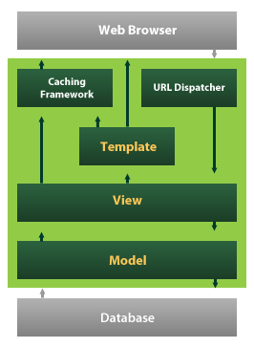
Django also provides an optional administrative create, read, update and delete interface that is generated dynamically through introspection and configured via admin models

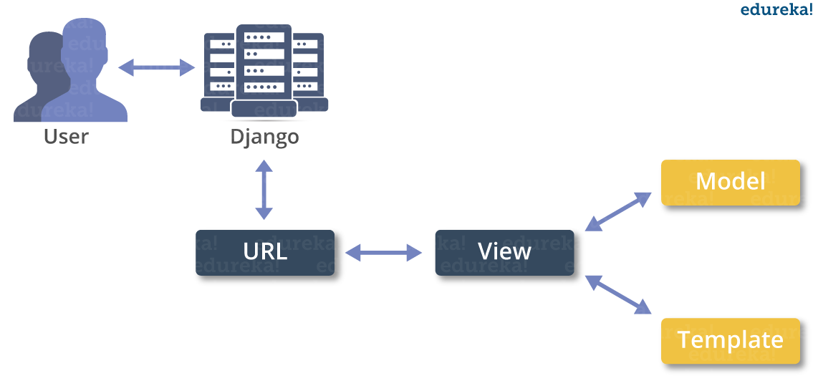
Create a Project
Whether you are on Windows or Linux, just get a terminal or a cmd prompt and navigate to the place you want your project to be created, then use this code −

$ django-admin startproject myproject
This will create a "myproject" folder with the following structure −

myproject/
manage.py
myproject/
__init__.py
settings.py
urls.py
wsgi.py
The Project Structure
The “myproject” folder is just your project container, it actually contains two elements −

manage.py − This file is kind of your project local django-admin for interacting with your project via command line (start the development server, sync db...). To get a full list of command accessible via manage.py you can use the code −

$ python manage.py help
The “myproject” subfolder − This folder is the actual python package of your project. It contains four files −

__init__.py − Just for python, treat this folder as package.

settings.py − As the name indicates, your project settings.

urls.py − All links of your project and the function to call. A kind of ToC of your project.

wsgi.py − If you need to deploy your project over WSGI.

Setting Up Your Project
Your project is set up in the subfolder myproject/settings.py. Following are some important options you might need to set −

DEBUG = True
This option lets you set if your project is in debug mode or not. Debug mode lets you get more information about your project's error. Never set it to ‘True’ for a live project. However, this has to be set to ‘True’ if you want the Django light server to serve static files. Do it only in the development mode.

DATABASES = {
'default': {
'ENGINE': 'django.db.backends.sqlite3',
'NAME': 'database.sql',
'USER': '',
'PASSWORD': '',
'HOST': '',
'PORT': '',
}
}
Database is set in the ‘Database’ dictionary. The example above is for SQLite engine. As stated earlier, Django also supports −

MySQL (django.db.backends.mysql)
PostGreSQL (django.db.backends.postgresql_psycopg2)
Oracle (django.db.backends.oracle) and NoSQL DB
MongoDB (django_mongodb_engine)
Before setting any new engine, make sure you have the correct db driver installed.

You can also set others options like: TIME_ZONE, LANGUAGE_CODE, TEMPLATE…

Now that your project is created and configured make sure it's working −

$ python manage.py runserver
You will get something like the following on running the above code −

Validating models...

0 errors found
September 03, 2015 - 11:41:50
Django version 1.6.11, using settings 'myproject.settings'
Starting development server at http://127.0.0.1:8000/
Quit the server with CONTROL-C.

A project is a sum of many applications. Every application has an objective and can be reused into another project, like the contact form on a website can be an application, and can be reused for others. See it as a module of your project.

Create an Application
We assume you are in your project folder. In our main “myproject” folder, the same folder then manage.py −

$ python manage.py startapp myapp
You just created myapp application and like project, Django create a “myapp” folder with the application structure −

myapp/
__init__.py
admin.py
models.py
tests.py
views.py
__init__.py − Just to make sure python handles this folder as a package.

admin.py − This file helps you make the app modifiable in the admin interface.

models.py − This is where all the application models are stored.

tests.py − This is where your unit tests are.

views.py − This is where your application views are.

Get the Project to Know About Your Application
At this stage we have our "myapp" application, now we need to register it with our Django project "myproject". To do so, update INSTALLED_APPS tuple in the settings.py file of your project (add your app name) −

INSTALLED_APPS = (
'django.contrib.admin',
'django.contrib.auth',
'django.contrib.contenttypes',
'django.contrib.sessions',
'django.contrib.messages',
'django.contrib.staticfiles',
'myapp',
)
Creating forms in Django, is really similar to creating a model. Here again, we just need to inherit from Django class and the class attributes will be the form fields. Let's add a forms.py file in myapp folder to contain our app forms. We will create a login form.

myapp/forms.py

#-*- coding: utf-8 -*-
from django import forms

class LoginForm(forms.Form):
user = forms.CharField(max_length = 100)
password = forms.CharField(widget = forms.PasswordInput())
As seen above, the field type can take "widget" argument for html rendering; in our case, we want the password to be hidden, not displayed. Many others widget are present in Django: DateInput for dates, CheckboxInput for checkboxes, etc.

Using Form in a View
There are two kinds of HTTP requests, GET and POST. In Django, the request object passed as parameter to your view has an attribute called "method" where the type of the request is set, and all data passed via POST can be accessed via the request.POST dictionary.

Let's create a login view in our myapp/views.py −

#-*- coding: utf-8 -*-
from myapp.forms import LoginForm

def login(request):
username = "not logged in"

if request.method == "POST":
#Get the posted form
MyLoginForm = LoginForm(request.POST)

if MyLoginForm.is_valid():
username = MyLoginForm.cleaned_data['username']
else:
MyLoginForm = Loginform()

return render(request, 'loggedin.html', {"username" : username})
The view will display the result of the login form posted through the loggedin.html. To test it, we will first need the login form template. Let's call it login.html.

<html>
<body>

<form name = "form" action = "{% url "myapp.views.login" %}"
method = "POST" >{% csrf_token %}

<div style = "max-width:470px;">
<center>
<input type = "text" style = "margin-left:20%;"
placeholder = "Identifiant" name = "username" />
</center>
</div>

<br>

<div style = "max-width:470px;">
<center>
<input type = "password" style = "margin-left:20%;"
placeholder = "password" name = "password" />
</center>
</div>

<br>

<div style = "max-width:470px;">
<center>

<button style = "border:0px; background-color:#4285F4; margin-top:8%;
height:35px; width:80%;margin-left:19%;" type = "submit"
value = "Login" >
<strong>Login</strong>
</button>

</center>
</div>

</form>

</body>
</html>
The template will display a login form and post the result to our login view above. You have probably noticed the tag in the template, which is just to prevent Cross-site Request Forgery (CSRF) attack on your site.

{% csrf_token %}
Once we have the login template, we need the loggedin.html template that will be rendered after form treatment.

<html>

<body>
You are : <strong>{{username}}</strong>
</body>

</html>
Now, we just need our pair of URLs to get started: myapp/urls.py

from django.conf.urls import patterns, url
from django.views.generic import TemplateView

urlpatterns = patterns('myapp.views',
url(r'^connection/',TemplateView.as_view(template_name = 'login.html')),
url(r'^login/', 'login', name = 'login'))
When accessing "/myapp/connection", we will get the following login.html template rendered −
Setting Up Sessions
In Django, enabling session is done in your project settings.py, by adding some lines to the MIDDLEWARE_CLASSES and the INSTALLED_APPS options. This should be done while creating the project, but it's always good to know, so MIDDLEWARE_CLASSES should have −

'django.contrib.sessions.middleware.SessionMiddleware'
And INSTALLED_APPS should have −

'django.contrib.sessions'
By default, Django saves session information in database (django_session table or collection), but you can configure the engine to store information using other ways like: in file or in cache.

When session is enabled, every request (first argument of any view in Django) has a session (dict) attribute.

Let's create a simple sample to see how to create and save sessions. We have built a simple login system before (see Django form processing chapter and Django Cookies Handling chapter). Let us save the username in a cookie so, if not signed out, when accessing our login page you won’t see the login form. Basically, let's make our login system we used in Django Cookies handling more secure, by saving cookies server side.

For this, first lets change our login view to save our username cookie server side −

def login(request):
username = 'not logged in'

if request.method == 'POST':
MyLoginForm = LoginForm(request.POST)

if MyLoginForm.is_valid():
username = MyLoginForm.cleaned_data['username']
request.session['username'] = username
else:
MyLoginForm = LoginForm()

return render(request, 'loggedin.html', {"username" : username}
Then let us create formView view for the login form, where we won’t display the form if cookie is set −

def formView(request):
if request.session.has_key('username'):
username = request.session['username']
return render(request, 'loggedin.html', {"username" : username})
else:
return render(request, 'login.html', {})
Now let us change the url.py file to change the url so it pairs with our new view −

from django.conf.urls import patterns, url
from django.views.generic import TemplateView

urlpatterns = patterns('myapp.views',
url(r'^connection/','formView', name = 'loginform'),
url(r'^login/', 'login', name = 'login'))
When accessing /myapp/connection, you will get to see the following page

SYSTEMS DESIGN
Introduction: Systems design is the process or art of defining the architecture, components, modules, interfaces, and data for a system to satisfy specified requirements. One could see it as the application of systems theory to product development. There is some overlap and synergy with the disciplines of systems analysis, systems architecture and systems engineering.
System Design Document

Overview
The System Design Document describes the system requirements, operating environment, system and subsystem architecture, files and database design, input formats, output layouts, human-machine interfaces, detailed design, processing logic, and external interfaces.
- INTRODUCTION
Purpose and Scope
This section provides a brief description of the Systems Design Document’s purpose and scope.
Project Executive Summary
This section provides a description of the project from a management perspective and an overview of the framework within which the conceptual system design was prepared. If appropriate, include the information discussed in the subsequent sections in the summary.
System Overview
This section describes the system in narrative form using non-technical terms. It should provide a high-level system architecture diagram showing a subsystem breakout of the system, if applicable. The high-level system architecture or subsystem diagrams should, if applicable, show interfaces to external systems. Supply a high-level context diagram for the system and subsystems, if applicable. Refer to the requirements trace ability matrix (RTM) in the Functional Requirements Document (FRD), to identify the allocation of the functional requirements into this design document.
Design Constraints
This section describes any constraints in the system design (reference any trade-off analyses conducted such, as resource use versus productivity, or conflicts with other systems) and includes any assumptions made by the project team in developing the system design.
Future Contingencies
This section describes any contingencies that might arise in the design of the system that may change the development direction. Possibilities include lack of interface agreements with outside agencies or unstable architectures at the time this document is produced. Address any possible workarounds or alternative plans.
Document Organization
This section describes the organization of the Systems Design Document.

Points of Contact
This section provides the organization code and title of the key points of contact (and alternates if appropriate) for the information system development effort. These points of contact should include the Project Manager, System Proponent, User Organization, Quality Assurance (QA) Manager, Security Manager, and Configuration Manager, as appropriate.
Project References
This section provides a bibliography of key project references and deliverables that have been produced before this point.
Glossary
Supply a glossary of all terms and abbreviations used in this document. If the glossary is several pages in length, it may be included as an appendix.
SYSTEM ARCHITECTURE
In this section, describe the system and/or subsystem(s) architecture for the project. References to external entities should be minimal, as they will be described in detail in Section 6, External Interfaces.
System Hardware Architecture
In this section, describe the overall system hardware and organization. Include a list of hardware components (with a brief description of each item) and diagrams showing the connectivity between the components. If appropriate, use subsections to address each subsystem.
System Software Architecture
In this section, describe the overall system software and organization. Include a list of software modules (this could include functions, subroutines, or classes), computer languages, and programming computer-aided software engineering tools (with a brief description of the function of each item). Use structured organization diagrams/object-oriented diagrams that show the various segmentation levels down to the lowest level. All features on the diagrams should have reference numbers and names. Include a narrative that expands on and enhances the understanding of the functional breakdown. If appropriate, use subsections to address each module.

Note: The diagrams should map to the FRD data flow diagrams, providing the physical process and data flow related to the FRD logical process and data flow.
Internal Communications Architecture
In this section, describe the overall communications within the system; for example, LANs, buses, etc. Include the communications architecture(s) being implemented, such as X.25, Token Ring, etc. Provide a diagram depicting the communications path(s) between the system and subsystem modules. If appropriate, use subsections to address each architecture being employed.

Note: The diagrams should map to the FRD context diagrams.
FILE AND DATABASE DESIGN
Interact with the Database Administrator (DBA) when preparing this section. The section should reveal the final design of all database management system (DBMS) files and the non-DBMS files associated with the system under development. Additional information may add as required for the particular project. Provide a comprehensive data dictionary showing data element name, type, length, source, validation rules, maintenance (create, read, update, delete (CRUD) capability), data stores, outputs, aliases, and description. Can be included as an appendix.
Database Management System Files
This section reveals the final design of the DBMS files and includes the following information, as appropriate (refer to the data dictionary):

- Refined logical model; provide normalized table layouts, entity relationship diagrams, and other logical design information
- A physical description of the DBMS schemas, sub-schemas, records, sets, tables, storage page sizes, etc.
- Access methods (such as indexed, via set, sequential, random access, sorted pointer array, etc.)
- Estimate of the DBMS file size or volume of data within the file, and data pages, including overhead resulting from access methods and free space
- Definition of the update frequency of the database tables, views, files, areas, records, sets, and data pages; estimate the number of transactions if the database is an online transaction-based system
Non-Database Management System Files
In this section, provide the detailed description of all non-DBMS files and include a narrative description of the usage of each file—including if the file is used for input, output, or both; if this file is a temporary file; an indication of which modules read and write the file, etc.; and file structures (refer to the data dictionary). As appropriate, the file structure information should:

- Identify record structures, record keys or indexes, and reference data elements within the records
- Define record length (fixed or maximum variable length) and blocking factors
- Define file access method—for example, index sequential, virtual sequential, random access, etc.
- Estimate the file size or volume of data within the file, including overhead resulting from file access methods
- Define the update frequency of the file; if the file is part of an online transaction-based system, provide the estimated number of transactions per unit time, and the statistical mean, mode, and distribution of those transactions
HUMAN-MACHINE INTERFACE
This section provides the detailed design of the system and subsystem inputs and outputs relative to the user/operator. Any additional information may be added to this section and may be organized according to whatever structure best presents the operator input and output designs. Depending on the particular nature of the project, it may be appropriate to repeat these sections at both the subsystem and design module levels. Additional information may be added to the subsections if the suggested lists are inadequate to describe the project inputs and outputs.
Inputs
This section is a description of the input media used by the operator for providing information to the system; show a mapping to the high-level data flows described in Section 1 .2.1, System Overview. For example, data entry screens, optical character readers, bar scanners, etc. If appropriate, the input record types, file structures, and database structures provided in Section 3, File and Database Design, may be referenced. Include data element definitions, or refer to the data dictionary.

Provide the layout of all input data screens or graphical user interfaces (GUTs) (for example, windows). Provide a graphic representation of each interface. Define all data elements associated with each screen or GUI, or reference the data dictionary.

This section should contain edit criteria for the data elements, including specific values, range of values, mandatory/optional, alphanumeric values, and length. Also address data entry controls to prevent edit bypassing.

Discuss the miscellaneous messages associated with operator inputs, including the following:

- Copies of form(s) if the input data are keyed or scanned for data entry from printed forms
- Description of any access restrictions or security considerations
- Each transaction name, code, and definition, if the system is a transaction-based processing system
Outputs
This section describes of the system output design relative to the user/operator; show a mapping to the high-level data flows described in Section 1.2.1. System outputs include reports, data display screens and GUIs, query results, etc. The output files are described in Section 3 and may be referenced in this section. The following should be provided, if appropriate:

- Identification of codes and names for reports and data display screens
- Description of report and screen contents (provide a graphic representation of each layout and define all data elements associated with the layout or reference the data dictionary)
- Description of the purpose of the output, including identification of the primary users
- Report distribution requirements, if any (include frequency for periodic reports)
- Description of any access restrictions or security considerations
DETAILED DESIGN
This section provides the information needed for a system development team to actually build and integrate the hardware components, code and integrate the software modules, and interconnect the hardware and software segments into a functional product. Additionally, this section addresses the detailed procedures for combining separate COTS packages into a single system. Every detailed requirement should map back to the FRD, and the mapping should be presented in an update to the RTM and include the RTM as an appendix to this design document.
Hardware Detailed Design
A hardware component is the lowest level of design granularity in the system. Depending on the design requirements, there may be one or more components per system. This section should provide enough detailed information about individual component requirements to correctly build and/or procure all the hardware for the system (or integrate COTS items).

If there are many components or if the component documentation is extensive, place it in an appendix or reference a separate document. Add additional diagrams and information, if necessary, to describe each component and its functions, adequately. Industry-standard component specification practices should be followed. For COTS procurements, if a specific vendor has been identified, include appropriate item names. Include the following information in the detailed component designs (as applicable):

- Power input requirements for each component
- Signal impedances and logic states
- Connector specifications (serial/parallel, 11-pin, male/female, etc.)
- Memory and/or storage space requirements
- Processor requirements (speed and functionality)
- Graphical representation depicting the number of hardware items (for example, monitors, printers, servers, I/O devices), and the relative positioning of the components to each other
- Cable type(s) and length(s)
- User interfaces (buttons, toggle switches, etc.)
- Hard drive/floppy drive/CD-ROM requirements
- Monitor resolution
Software Detailed Design
A software module is the lowest level of design granularity in the system. Depending on the software development approach, there may be one or more modules per system. This section should provide enough detailed information about logic and data necessary to completely write source code for all modules in the system (and/or integrate COTS software programs).

If there are many modules or if the module documentation is extensive, place it in an appendix or reference a separate document. Add additional diagrams and information, if necessary, to describe each module, its functionality, and its hierarchy. Industry-standard module specification practices should be followed. Include the following information in the detailed module designs:

- A narrative description of each module, its function(s), the conditions under which it is used (called or scheduled for execution), its overall processing, logic, interfaces to other modules, interfaces to external systems, security requirements, etc.; explain any algorithms used by the module in detail
- For COTS packages, specify any call routines or bridging programs to integrate the package with the system and/or other COTS packages (for example, Dynamic Link Libraries)
- Data elements, record structures, and file structures associated with module input and output
- Graphical representation of the module processing, logic, flow of control, and algorithms, using an accepted diagramming approach (for example, structure charts, action diagrams, flowcharts, etc.)
- Data entry and data output graphics; define or reference associated data elements; if the project is large and complex or if the detailed module designs will be incorporated into a separate document, then it may be appropriate to repeat the screen information in this section
- Report layout
Internal Communications Detailed Design
If the system includes more than one component there may be a requirement for internal communications to exchange information, provide commands, or support input/output functions. This section should provide enough detailed information about the communication requirements to correctly build and/or procure the communications components for the system. Include the following information in the detailed designs (as appropriate):

- The number of servers and clients to be included on each area network
- Specifications for bus timing requirements and bus control
- Format(s) for data being exchanged between components
- Graphical representation of the connectivity between components, showing the direction of data flow (if applicable), and approximate distances between components; information should provide enough detail to support the procurement of hardware to complete the installation at a given location
- LAN topology
EXTERNAL INTERFACES
External systems are any systems that are not within the scope of the system under development, regardless whether the other systems are managed by the State or another agency. In this section, describe the electronic interface(s) between this system and each of the other systems and/or subsystem(s), emphasizing the point of view of the system being developed.
Interface Architecture
In this section, describe the interface(s) between the system being developed and other systems; for example, batch transfers, queries, etc. Include the interface architecture(s) being implemented, such as wide area networks, gateways, etc. Provide a diagram depicting the communications path(s) between this system and each of the other systems, which should map to the context diagrams in Section 1.2.1. If appropriate, use subsections to address each interface being implemented.
Interface Detailed Design
For each system that provides information exchange with the system under development, there is a requirement for rules governing the interface. This section should provide enough detailed information about the interface requirements to correctly format, transmit, and/or receive data across the interface. Include the following information in the detailed design for each interface (as appropriate):

- The data format requirements; if there is a need to reformat data before they are transmitted or after incoming data is received, tools and/or methods for the reformat process should be defined
- Specifications for hand-shaking protocols between the two systems; include the content and format of the information to be included in the hand-shake messages, the timing for exchanging these messages, and the steps to be taken when errors are identified
- Format(s) for error reports exchanged between the systems; should address the disposition of error reports; for example, retained in a file, sent to a printer, flag/alarm sent to the operator, etc.
- Graphical representation of the connectivity between systems, showing the direction of data flow
- Query and response descriptions

If a formal Interface Control Document (ICD) exists for a given interface, the information can be copied, or the ICD can be referenced in this section.
SYSTEM INTEGRITY CONTROLS
Sensitive systems use information for which the loss, misuse, modification of, or unauthorized access to that information could affect the conduct of State programs, or the privacy to which individuals are entitled.

Developers of sensitive State systems are required to develop specifications for the following minimum levels of control:

- Internal security to restrict access of critical data items to only those access types required by users
- Audit procedures to meet control, reporting, and retention period requirements for operational and management reports
- Application audit trails to dynamically audit retrieval access to designated critical data
- Standard Tables to be used or requested for validating data fields
- Verification processes for additions, deletions, or updates of critical data
Ability to identify all audit information by user identification, network terminal identification, date, time, and data accessed or changed.

PROPOSED SYSTEM
SYSTEM ARCHITECTURE
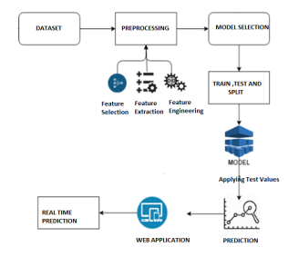
MODULES:
DATASET: The beneft of using these words based on their entropy score in the characteristic-set is that we have been capable of lessen uncertainty in the prediction final results as those phrases have a exceptional effect of frequency count in spam and non-spam YouTube.
PREPROCESSING: Before starting with preparation preprocessing of the messages must be done. First all the characters must be in lowercase. The word which is both in uppercase and lowercase must be considered as same words and not as two different words. Then tokenization must be done for each message in the data set.
FEATURE SELECTION: The main advantage of using the words present in the dataset is that it is capable of reducing uncertainty in the prediction of the final results as those phrases have a remarkable effect of frequency count in spam and ham comments in YouTube.
FEATURE EXTRACTION AND FEATURE ENGINEERING; Attribute significance is a supervised characteristic that ranks attributes in a step by step manner with their significance in predicting an aim. Here Count Vectorizer is used which convert a “collection of text documents to a matrix of token counts . This undergoes the following technique:
N-grams: N-grams is used to improve the accuracy. It is dealt with single word but when there are two mutual words the complete meaning will be changed. So, the variation of accuracy is better occurred when text is split into token of two or more words rather than being a single word.
ANALYZER: “Whether the feature should be made of word or character n-grams. Option ‘char_wb’ creates character n-grams only from text inside word boundaries; n-grams at the edges of words are padded with space.”
VOCABULARY: “Either a Mapping (e.g., a dicts) where keys are terms and values are indices in the feature matrix, or an iterable over terms. If not given, a vocabulary is determined from the input documents. Indices in the mapping should not be repeated and should not have any gap between 0 and the largest index.
BINARY: If True, all non zero counts are set to 1. This is useful for discrete probabilistic models that model binary events rather than integer counts.”
MODEL BUILDING After Preprocessing there has to be a way of constructing a version to keep the abilities of the function of the project in accordance to the labeled model, which is built as per the Supervised set of rules.
MAX_FEATURES: If not None, build a vocabulary that only consider the top max_features ordered by term frequency across the corpus. This parameter is ignored if vocabulary is not None.” Adaboost is the boosting algorithm which is adapted in solving practices .It helps to combine many weak classifiers to a single strong classifier. It first separates the weak learners called as decision stumps which means the decision tree with single split. It then separates the datasets based on the level of difficulty, it puts more weight on the instances which are more tricky and difficult ,and less weight on the ones which are handled properly. The decision stumps will be made into two subsets and a threshold value will be calculated all the data will be either above or below the threshold value. It is moderately accurate on dataset because it failed when we get a value which is an exception from threshold value. Decision tree is a series of true or false questions that are asked about our data eventually leading to continuous value or predicted. In this it tries to form nodes in which it contains high proportion of data points from a particular or single class by finding the values in features which divides the data into classes. It is a nonlinear model which is built by many linear boundaries, here for a model we give both label and features so that it will understand to classify points based on features, due to overfitting in the data it is not accurate compared with other algorithms. Random forest has number of blocks of decision trees together in a single thing, so it is not accurate compared with other algorithms. Logisitic regression is used for prediction of binomial or multinomial values of a variable. It uses a statistical approach to find the outcome. The outcome is binary in nature. It uses a logit function for the prediction of probability of occurrence of binary outcome, it follows bernoulis distribution, so the outcome here will be accurate either x or y. Here it works on dataset and predicts x or y that is spam or ham.
ALGORITHMS:

DECISION TREE CLASSIFICATION ALGORITHM
- Decision Tree is a Supervised learning technique that can be used for both classification and Regression problems, but mostly it is preferred for solving Classification problems. It is a tree-structured classifier, where internal nodes represent the features of a dataset, branches represent the decision rules and each leaf node represents the outcome.
- In a Decision tree, there are two nodes, which are the Decision Node and Leaf Node. Decision nodes are used to make any decision and have multiple branches, whereas Leaf nodes are the output of those decisions and do not contain any further branches.
- The decisions or the test are performed on the basis of features of the given dataset.
- It is a graphical representation for getting all the possible solutions to a problem/decision based on given conditions.
- It is called a decision tree because, similar to a tree, it starts with the root node, which expands on further branches and constructs a tree-like structure.
- In order to build a tree, we use the CART algorithm, which stands for Classification and Regression Tree algorithm.
- A decision tree simply asks a question, and based on the answer (Yes/No), it further split the tree into subtrees.
- Below diagram explains the general structure of a decision tree:

Note: A decision tree can contain categorical data (YES/NO) as well as numeric data.
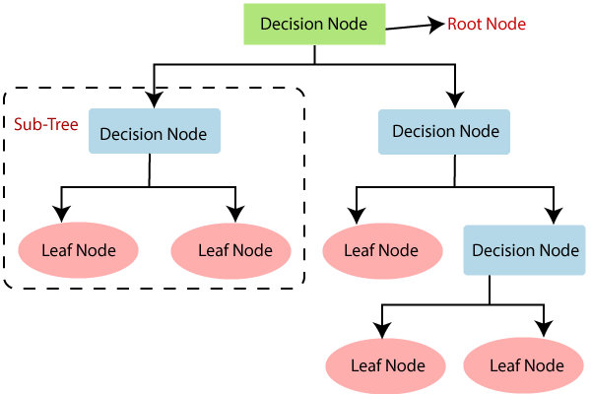

Why use Decision Trees?
There are various algorithms in Machine learning, so choosing the best algorithm for the given dataset and problem is the main point to remember while creating a machine learning model. Below are the two reasons for using the Decision tree:
- Decision Trees usually mimic human thinking ability while making a decision, so it is easy to understand.
- The logic behind the decision tree can be easily understood because it shows a tree-like structure.

Decision Tree Terminologies
• Root Node: Root node is from where the decision tree starts. It represents the entire dataset, which further gets divided into two or more homogeneous sets.
• Leaf Node: Leaf nodes are the final output node, and the tree cannot be segregated further after getting a leaf node.
• Splitting: Splitting is the process of dividing the decision node/root node into sub-nodes according to the given conditions.
• Branch/Sub Tree: A tree formed by splitting the tree.
• Pruning: Pruning is the process of removing the unwanted branches from the tree.
• Parent/Child node: The root node of the tree is called the parent node, and other nodes are called the child nodes.
How does the Decision Tree algorithm Work?
In a decision tree, for predicting the class of the given dataset, the algorithm starts from the root node of the tree. This algorithm compares the values of root attribute with the record (real dataset) attribute and, based on the comparison, follows the branch and jumps to the next node.
For the next node, the algorithm again compares the attribute value with the other sub-nodes and move further. It continues the process until it reaches the leaf node of the tree. The complete process can be better understood using the below algorithm:
- Step-1: Begin the tree with the root node, says S, which contains the complete dataset.
- Step-2: Find the best attribute in the dataset using Attribute Selection Measure (ASM).
- Step-3: Divide the S into subsets that contains possible values for the best attributes.
- Step-4: Generate the decision tree node, which contains the best attribute.
- Step-5: Recursively make new decision trees using the subsets of the dataset created in step -3. Continue this process until a stage is reached where you cannot further classify the nodes and called the final node as a leaf node.
Example: Suppose there is a candidate who has a job offer and wants to decide whether he should accept the offer or Not. So, to solve this problem, the decision tree starts with the root node (Salary attribute by ASM). The root node splits further into the next decision node (distance from the office) and one leaf node based on the corresponding labels. The next decision node further gets split into one decision node (Cab facility) and one leaf node. Finally, the decision node splits into two leaf nodes (Accepted offers and Declined offer). Consider the below diagram:
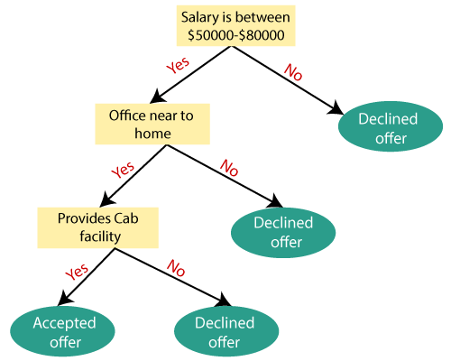

Attribute Selection Measures
While implementing a Decision tree, the main issue arises that how to select the best attribute for the root node and for sub-nodes. So, to solve such problems there is a technique which is called as Attribute selection measure or ASM. By this measurement, we can easily select the best attribute for the nodes of the tree. There are two popular techniques for ASM, which are:
- Information Gain
- Gini Index

1. Information Gain:
- Information gain is the measurement of changes in entropy after the segmentation of a dataset based on an attribute.
- It calculates how much information a feature provides us about a class.
- According to the value of information gain, we split the node and build the decision tree.
- A decision tree algorithm always tries to maximize the value of information gain, and a node/attribute having the highest information gain is split first. It can be calculated using the below formula:
- Information Gain= Entropy(S)- [(Weighted Avg) *Entropy(each feature)
Entropy: Entropy is a metric to measure the impurity in a given attribute. It specifies randomness in data. Entropy can be calculated as:
Entropy(s)= -P(yes)log2 P(yes)- P(no) log2 P(no)
Where,
- S= Total number of samples
- P(yes)= probability of yes
- P(no)= probability of no

2. Gini Index:
- Gini index is a measure of impurity or purity used while creating a decision tree in the CART(Classification and Regression Tree) algorithm.
- An attribute with the low Gini index should be preferred as compared to the high Gini index.
- It only creates binary splits, and the CART algorithm uses the Gini index to create binary splits.
- Gini index can be calculated using the below formula:
Gini Index= 1- ∑_{j}P_{j}²

Pruning: Getting an Optimal Decision tree
Pruning is a process of deleting the unnecessary nodes from a tree in order to get the optimal decision tree.
A too-large tree increases the risk of overfitting, and a small tree may not capture all the important features of the dataset. Therefore, a technique that decreases the size of the learning tree without reducing accuracy is known as Pruning. There are mainly two types of tree pruning technology used:
- Cost Complexity Pruning
- Reduced Error Pruning.

Advantages of the Decision Tree
- It is simple to understand as it follows the same process which a human follow while making any decision in real-life.
- It can be very useful for solving decision-related problems.
- It helps to think about all the possible outcomes for a problem.
- There is less requirement of data cleaning compared to other algorithms.

Disadvantages of the Decision Tree
- The decision tree contains lots of layers, which makes it complex.
- It may have an overfitting issue, which can be resolved using the Random Forest algorithm.
- For more class labels, the computational complexity of the decision tree may increase.

Python Implementation of Decision Tree
Now we will implement the Decision tree using Python. For this, we will use the dataset "user_data.csv," which we have used in previous classification models. By using the same dataset, we can compare the Decision tree classifier with other classification models such as KNN SVM, LogisticRegression, etc.
Steps will also remain the same, which are given below:
- Data Pre-processing step
- Fitting a Decision-Tree algorithm to the Training set
- Predicting the test result
- Test accuracy of the result(Creation of Confusion matrix)
- Visualizing the test set result.

RANDOM FOREST ALGORITHM
Random Forest is a popular machine learning algorithm that belongs to the supervised learning technique. It can be used for both Classification and Regression problems in ML. It is based on the concept of ensemble learning, which is a process of combining multiple classifiers to solve a complex problem and to improve the performance of the model.
As the name suggests, "Random Forest is a classifier that contains a number of decision trees on various subsets of the given dataset and takes the average to improve the predictive accuracy of that dataset." Instead of relying on one decision tree, the random forest takes the prediction from each tree and based on the majority votes of predictions, and it predicts the final output.
The greater number of trees in the forest leads to higher accuracy and prevents the problem of overfitting.
The below diagram explains the working of the Random Forest algorithm:
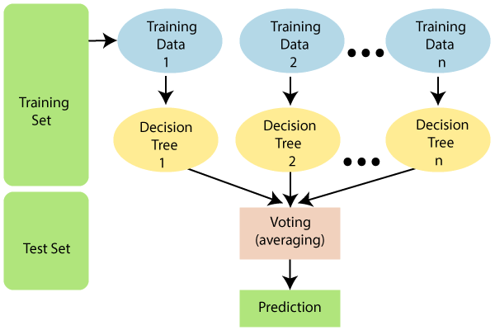

Note: To better understand the Random Forest Algorithm, you should have knowledge of the Decision Tree Algorithm.

Assumptions for Random Forest
Since the random forest combines multiple trees to predict the class of the dataset, it is possible that some decision trees may predict the correct output, while others may not. But together, all the trees predict the correct output. Therefore, below are two assumptions for a better Random forest classifier:
- There should be some actual values in the feature variable of the dataset so that the classifier can predict accurate results rather than a guessed result.
- The predictions from each tree must have very low correlations.

Why use Random Forest?
Below are some points that explain why we should use the Random Forest algorithm:
<="" li="">
- It takes less training time as compared to other algorithms.
- It predicts output with high accuracy, even for the large dataset it runs efficiently.
- It can also maintain accuracy when a large proportion of data is missing.

How does Random Forest algorithm work?
Random Forest works in two-phase first is to create the random forest by combining N decision tree, and second is to make predictions for each tree created in the first phase.
The Working process can be explained in the below steps and diagram:
Step-1: Select random K data points from the training set.
Step-2: Build the decision trees associated with the selected data points (Subsets).
Step-3: Choose the number N for decision trees that you want to build.
Step-4: Repeat Step 1 & 2.
Step-5: For new data points, find the predictions of each decision tree, and assign the new data points to the category that wins the majority votes.
The working of the algorithm can be better understood by the below example:
Example: Suppose there is a dataset that contains multiple fruit images. So, this dataset is given to the Random forest classifier. The dataset is divided into subsets and given to each decision tree. During the training phase, each decision tree produces a prediction result, and when a new data point occurs, then based on the majority of results, the Random Forest classifier predicts the final decision. Consider the below image:
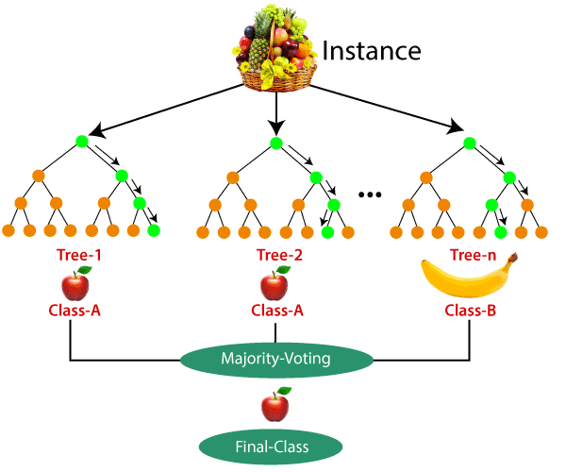

Applications of Random Forest
There are mainly four sectors where Random forest mostly used:
- Banking: Banking sector mostly uses this algorithm for the identification of loan risk.
- Medicine: With the help of this algorithm, disease trends and risks of the disease can be identified.
- Land Use: We can identify the areas of similar land use by this algorithm.
- Marketing: Marketing trends can be identified using this algorithm.

Advantages of Random Forest
- Random Forest is capable of performing both Classification and Regression tasks.
- It is capable of handling large datasets with high dimensionality.
- It enhances the accuracy of the model and prevents the overfitting issue.

Disadvantages of Random Forest
- Although random forest can be used for both classification and regression tasks, it is not more suitable for Regression tasks.

LINEAR REGRESSION
Linear regression is one of the easiest and most popular Machine Learning algorithms. It is a statistical method that is used for predictive analysis. Linear regression makes predictions for continuous/real or numeric variables such as sales, salary, age, product price, etc.
Linear regression algorithm shows a linear relationship between a dependent (y) and one or more independent (y) variables, hence called as linear regression. Since linear regression shows the linear relationship, which means it finds how the value of the dependent variable is changing according to the value of the independent variable.
The linear regression model provides a sloped straight line representing the relationship between the variables. Consider the below image:
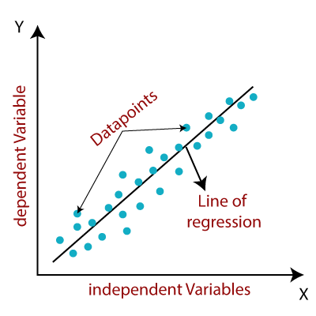
Mathematically, we can represent a linear regression as:
y= a₀+a₁x+ ε
Here,
Y= Dependent Variable (Target Variable)
X= Independent Variable (predictor Variable)
a0= intercept of the line (Gives an additional degree of freedom)
a1 = Linear regression coefficient (scale factor to each input value).
ε = random error
The values for x and y variables are training datasets for Linear Regression model representation.

Types of Linear Regression
Linear regression can be further divided into two types of the algorithm:
- Simple Linear Regression:
If a single independent variable is used to predict the value of a numerical dependent variable, then such a Linear Regression algorithm is called Simple Linear Regression.
- Multiple Linear regression:
If more than one independent variable is used to predict the value of a numerical dependent variable, then such a Linear Regression algorithm is called Multiple Linear Regression.

Linear Regression Line
A linear line showing the relationship between the dependent and independent variables is called a regression line. A regression line can show two types of relationship:
- Positive Linear Relationship:
If the dependent variable increases on the Y-axis and independent variable increases on X-axis, then such a relationship is termed as a Positive linear relationship.
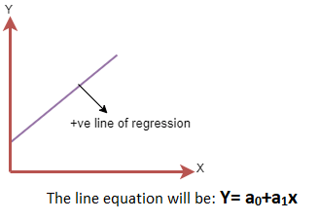
- Negative Linear Relationship:
If the dependent variable decreases on the Y-axis and independent variable increases on the X-axis, then such a relationship is called a negative linear relationship.
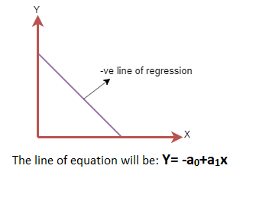

Finding the best fit line:
When working with linear regression, our main goal is to find the best fit line that means the error between predicted values and actual values should be minimized. The best fit line will have the least error.
The different values for weights or the coefficient of lines (a₀, a₁) gives a different line of regression, so we need to calculate the best values for a₀ and a₁ to find the best fit line, so to calculate this we use cost function.

Cost function-
- The different values for weights or coefficient of lines (a₀, a₁) gives the different line of regression, and the cost function is used to estimate the values of the coefficient for the best fit line.
- Cost function optimizes the regression coefficients or weights. It measures how a linear regression model is performing.
- We can use the cost function to find the accuracy of the mapping function, which maps the input variable to the output variable. This mapping function is also known as Hypothesis function.
For Linear Regression, we use the Mean Squared Error (MSE) cost function, which is the average of squared error occurred between the predicted values and actual values. It can be written as:
For the above linear equation, MSE can be calculated as:
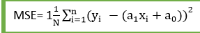
Where,
N=Total number of observation
Yi = Actual value
(a1x_{i}+a₀)= Predicted value.
Residuals: The distance between the actual value and predicted values is called residual. If the observed points are far from the regression line, then the residual will be high, and so cost function will high. If the scatter points are close to the regression line, then the residual will be small and hence the cost function.

Gradient Descent:
- Gradient descent is used to minimize the MSE by calculating the gradient of the cost function.
- A regression model uses gradient descent to update the coefficients of the line by reducing the cost function.
- It is done by a random selection of values of coefficient and then iteratively update the values to reach the minimum cost function.

Model Performance:
The Goodness of fit determines how the line of regression fits the set of observations. The process of finding the best model out of various models is called optimization. It can be achieved by below method:
1. R-squared method:
- R-squared is a statistical method that determines the goodness of fit.
- It measures the strength of the relationship between the dependent and independent variables on a scale of 0-100%.
- The high value of R-square determines the less difference between the predicted values and actual values and hence represents a good model.
- It is also called a coefficient of determination, or coefficient of multiple determination for multiple regression.
- It can be calculated from the below formula:
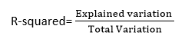

Assumptions of Linear Regression
Below are some important assumptions of Linear Regression. These are some formal checks while building a Linear Regression model, which ensures to get the best possible result from the given dataset.
- Linear relationship between the features and target:
Linear regression assumes the linear relationship between the dependent and independent variables.
- Small or no multicollinearity between the features:
Multicollinearity means high-correlation between the independent variables. Due to multicollinearity, it may difficult to find the true relationship between the predictors and target variables. Or we can say, it is difficult to determine which predictor variable is affecting the target variable and which is not. So, the model assumes either little or no multicollinearity between the features or independent variables.
- Homoscedasticity Assumption:
Homoscedasticity is a situation when the error term is the same for all the values of independent variables. With homoscedasticity, there should be no clear pattern distribution of data in the scatter plot.
- Normal distribution of error terms:
Linear regression assumes that the error term should follow the normal distribution pattern. If error terms are not normally distributed, then confidence intervals will become either too wide or too narrow, which may cause difficulties in finding coefficients.
It can be checked using the q-q plot. If the plot shows a straight line without any deviation, which means the error is normally distributed.
- No autocorrelations:
The linear regression model assumes no autocorrelation in error terms. If there will be any correlation in the error term, then it will drastically reduce the accuracy of the model. Autocorrelation usually occurs if there is a dependency between residual errors.

System Design
Data Flow Diagram
User
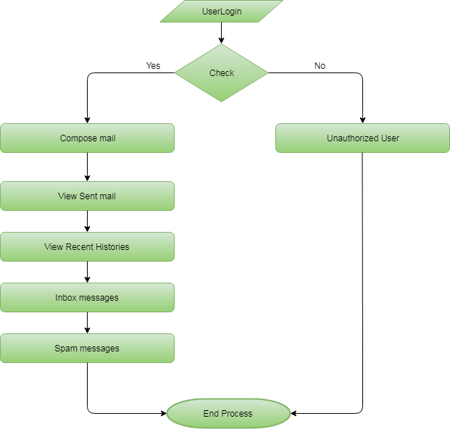

Admin
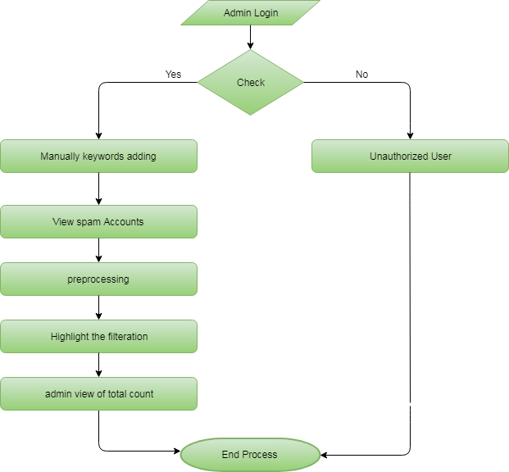

Usecase Diagram
User
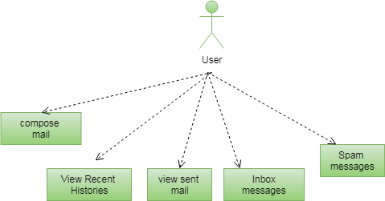

Admin
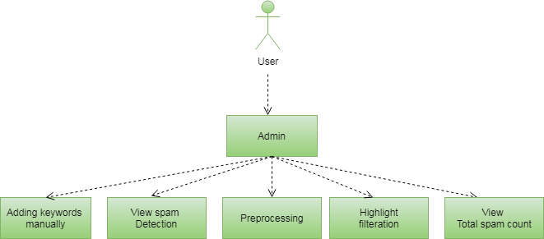

Class Diagram
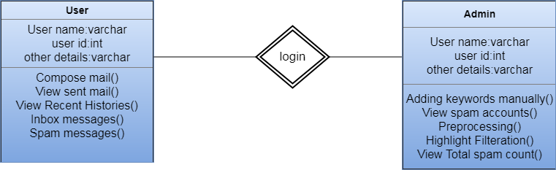
Sequence Diagram
User
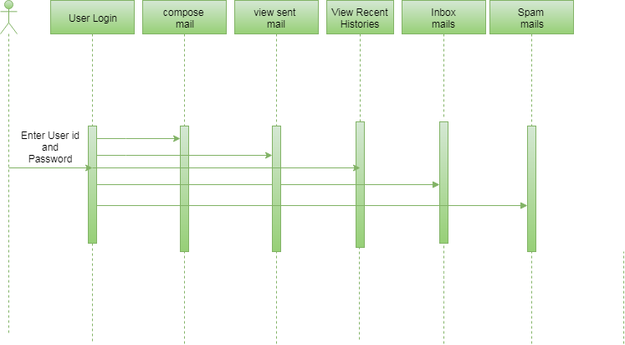

Admin
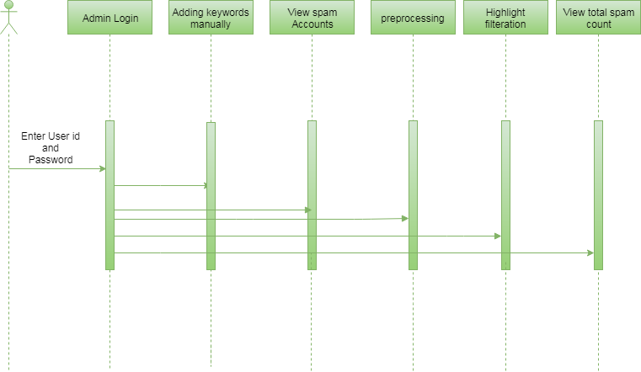
Activity Diagram
User
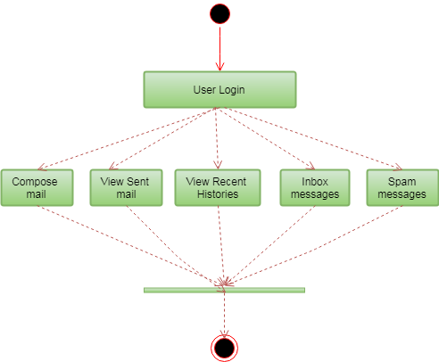

Admin
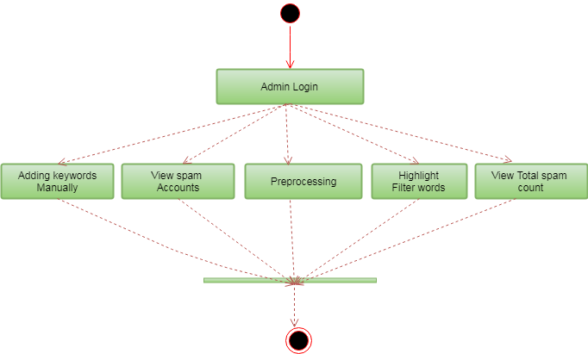
Component Diagram
User
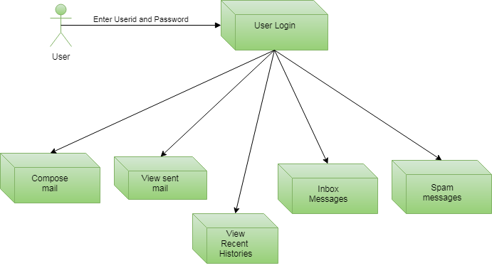
Admin
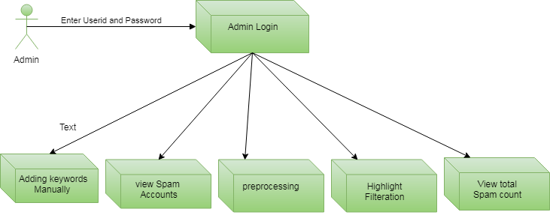

ER Diagram
User
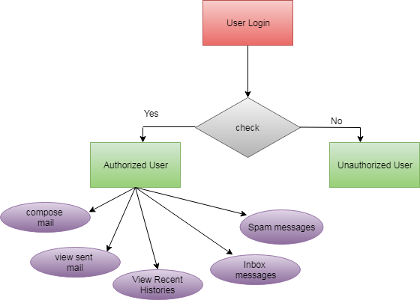
Admin
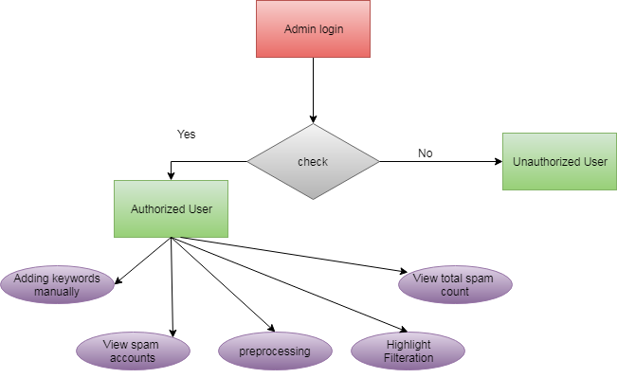

SYSTEM TEST
The purpose of testing is to discover errors. Testing is the process of trying to discover every conceivable fault or weakness in a work product. It provides a way to check the functionality of components, sub assemblies, assemblies and/or a finished product It is the process of exercising software with the intent of ensuring that the Software system meets its requirements and user expectations and does not fail in an unacceptable manner. There are various types of test. Each test type addresses a specific testing requirement.

TYPES OF TESTUnit testing
Unit testing involves the design of test cases that validate that the internal program logic is functioning properly, and that program inputs produce valid outputs. All decision branches and internal code flow should be validated. It is the testing of individual software units of the application .it is done after the completion of an individual unit before integration. This is a structural testing, that relies on knowledge of its construction and is invasive. Unit tests perform basic tests at component level and test a specific business process, application, and/or system configuration. Unit tests ensure that each unique path of a business process performs accurately to the documented specifications and contains clearly defined inputs and expected results.

Integration testing
Integration tests are designed to test integrated software components to determine if they actually run as one program. Testing is event driven and is more concerned with the basic outcome of screens or fields. Integration tests demonstrate that although the components were individually satisfaction, as shown by successfully unit testing, the combination of components is correct and consistent. Integration testing is specifically aimed at exposing the problems that arise from the combination of components.

Functional test

Functional tests provide systematic demonstrations that functions tested are available as specified by the business and technical requirements, system documentation, and user manuals.
Functional testing is centered on the following items:
Valid Input : identified classes of valid input must be accepted.
Invalid Input : identified classes of invalid input must be rejected.
Functions : identified functions must be exercised.
Output : identified classes of application outputs must be exercised.
Systems/Procedures : interfacing systems or procedures must be invoked.
Organization and preparation of functional tests is focused on requirements, key functions, or special test cases. In addition, systematic coverage pertaining to identify Business process flows; data fields, predefined processes, and successive processes must be considered for testing. Before functional testing is complete, additional tests are identified and the effective value of current tests is determined.

System Test
System testing ensures that the entire integrated software system meets requirements. It tests a configuration to ensure known and predictable results. An example of system testing is the configuration oriented system integration test. System testing is based on process descriptions and flows, emphasizing pre-driven process links and integration points.

White Box Testing
White Box Testing is a testing in which in which the software tester has knowledge of the inner workings, structure and language of the software, or at least its purpose. It is purpose. It is used to test areas that cannot be reached from a black box level.

Black Box Testing

Black Box Testing is testing the software without any knowledge of the inner workings, structure or language of the module being tested. Black box tests, as most other kinds of tests, must be written from a definitive source document, such as specification or requirements document, such as specification or requirements document. It is a testing in which the software under test is treated, as a black box .you cannot “see” into it. The test provides inputs and responds to outputs without considering how the software works.
Unit Testing
Unit testing is usually conducted as part of a combined code and unit test phase of the software lifecycle, although it is not uncommon for coding and unit testing to be conducted as two distinct phases.
Test strategy and approach
Field testing will be performed manually and functional tests will be written in detail.
Test objectives
- All field entries must work properly.
- Pages must be activated from the identified link.
- The entry screen, messages and responses must not be delayed.

Features to be tested
- Verify that the entries are of the correct format
- No duplicate entries should be allowed
- All links should take the user to the correct page.

Integration Testing
Software integration testing is the incremental integration testing of two or more integrated software components on a single platform to produce failures caused by interface defects.
The task of the integration test is to check that components or software applications, e.g. components in a software system or – one step up – software applications at the company level – interact without error.
Test Results: All the test cases mentioned above passed successfully. No defects encountered.

Acceptance Testing
User Acceptance Testing is a critical phase of any project and requires significant participation by the end user. It also ensures that the system meets the functional requirements.
Test Results: All the test cases mentioned above passed successfully. No defects encountered.
RESULTS
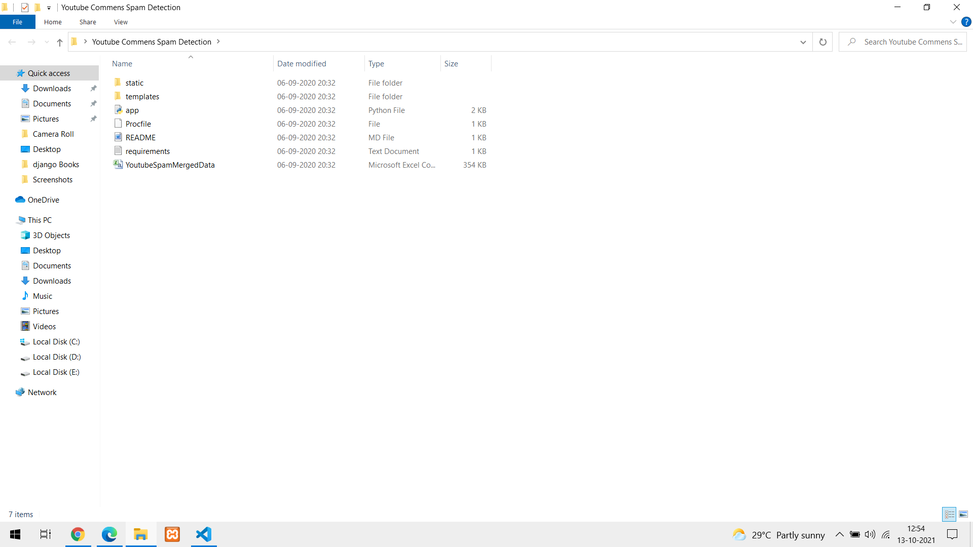

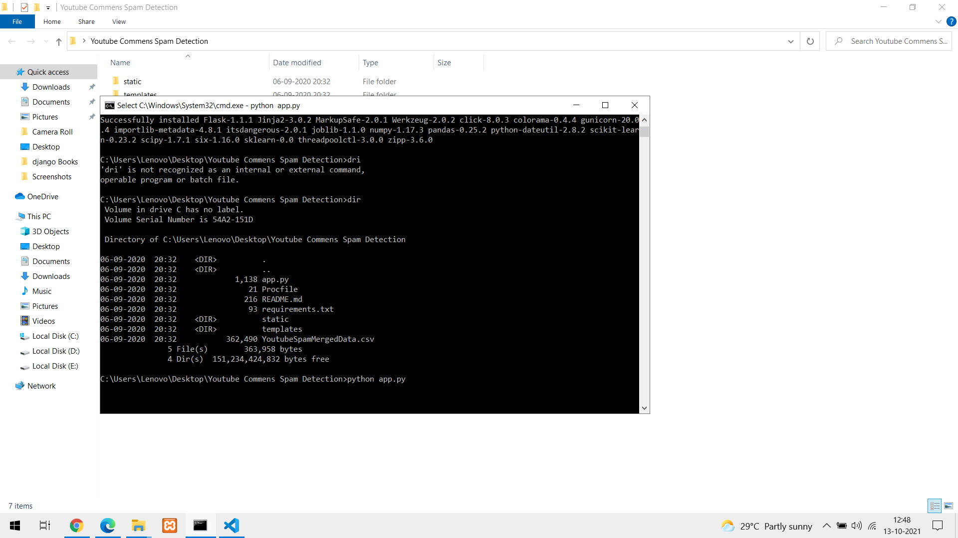

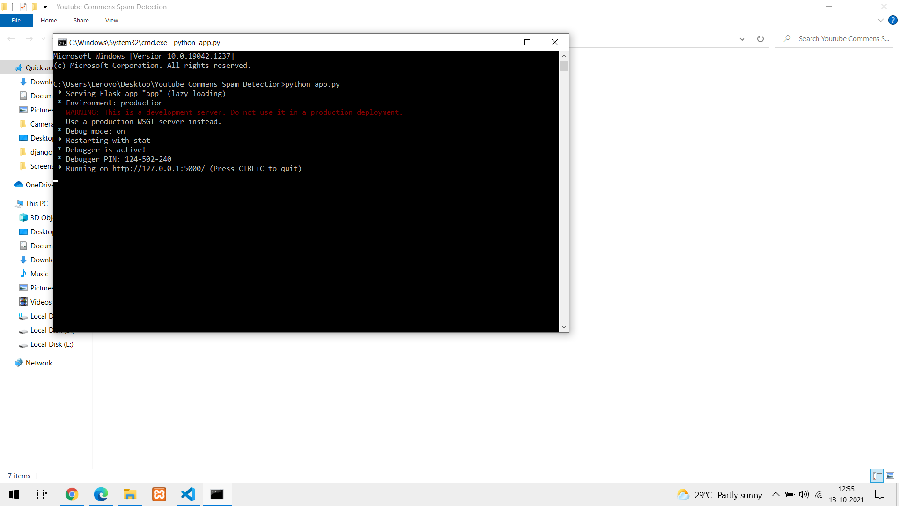

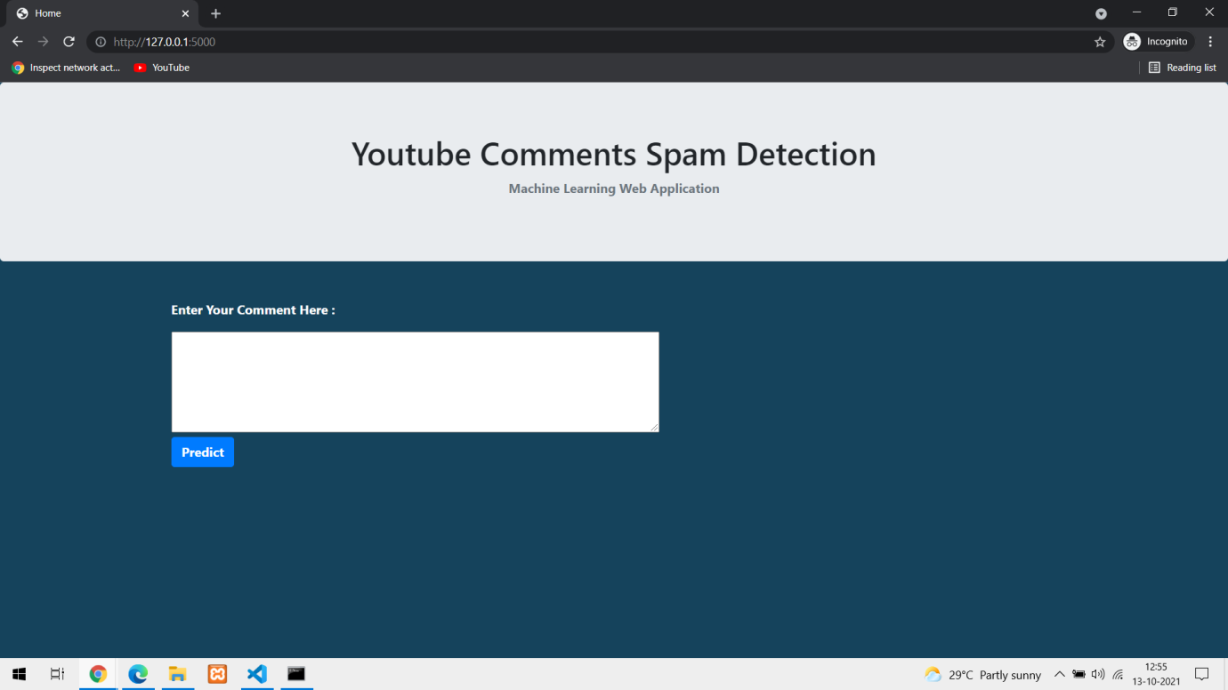

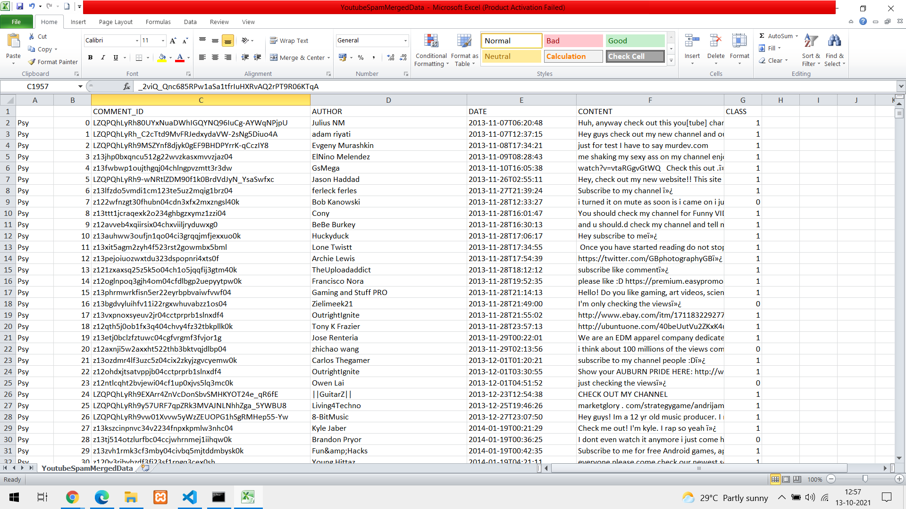

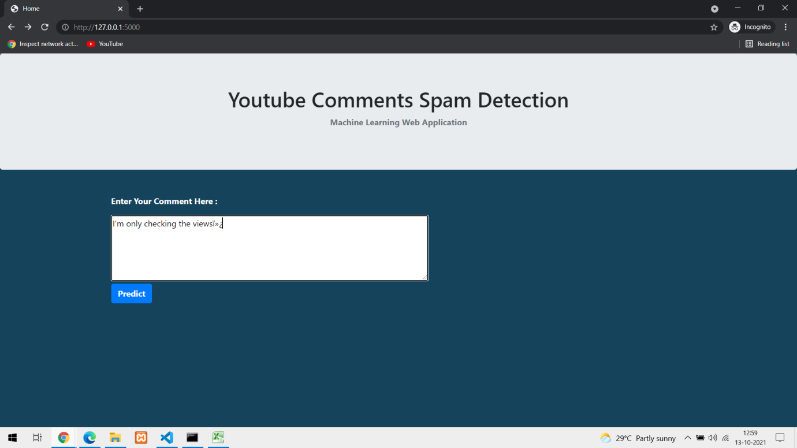

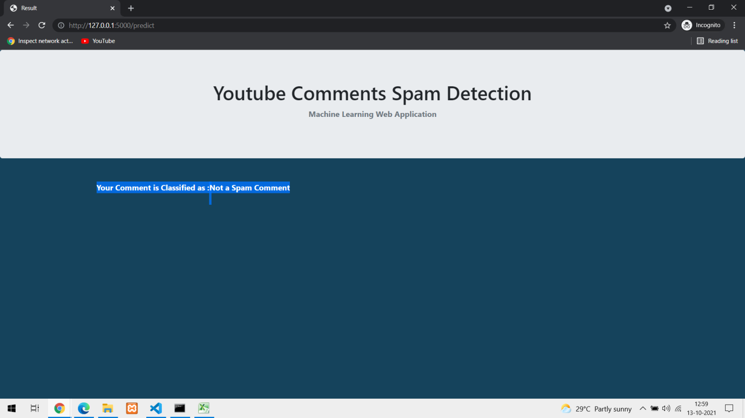

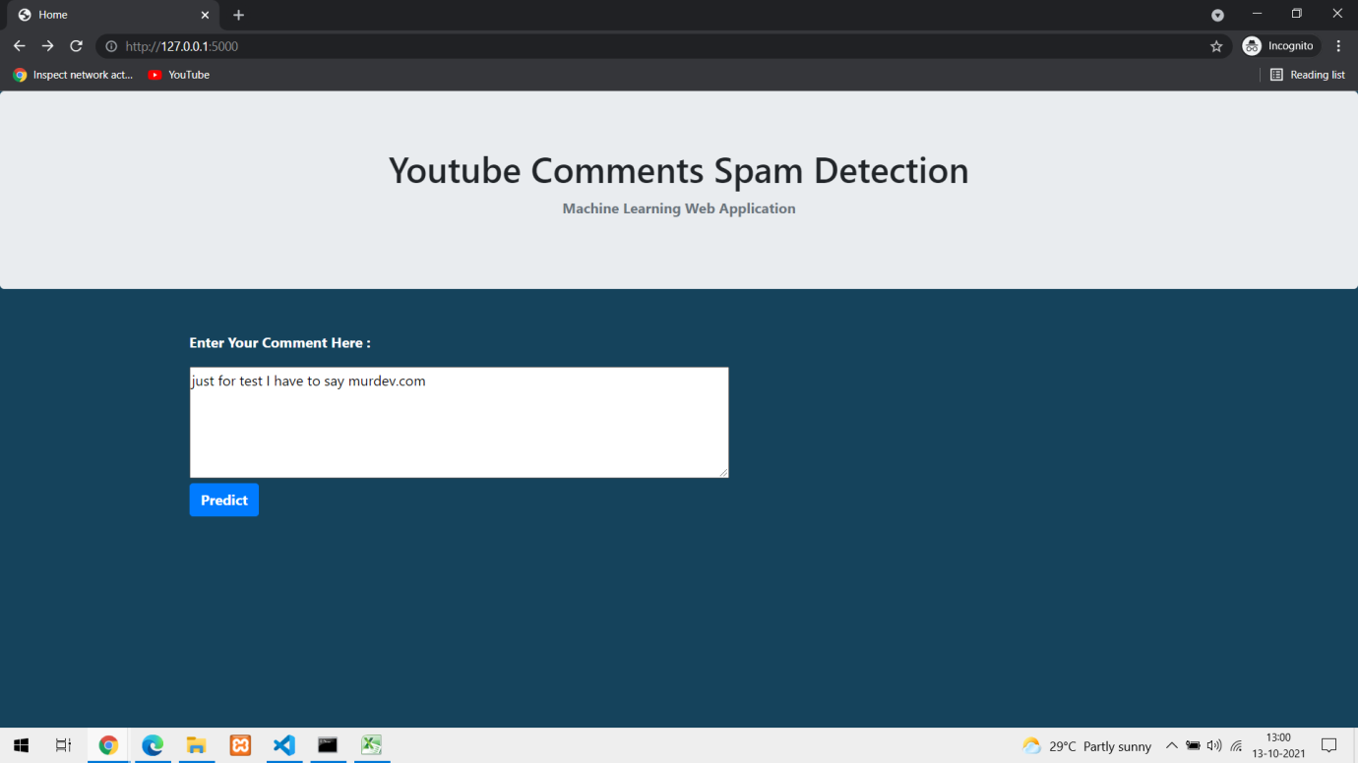

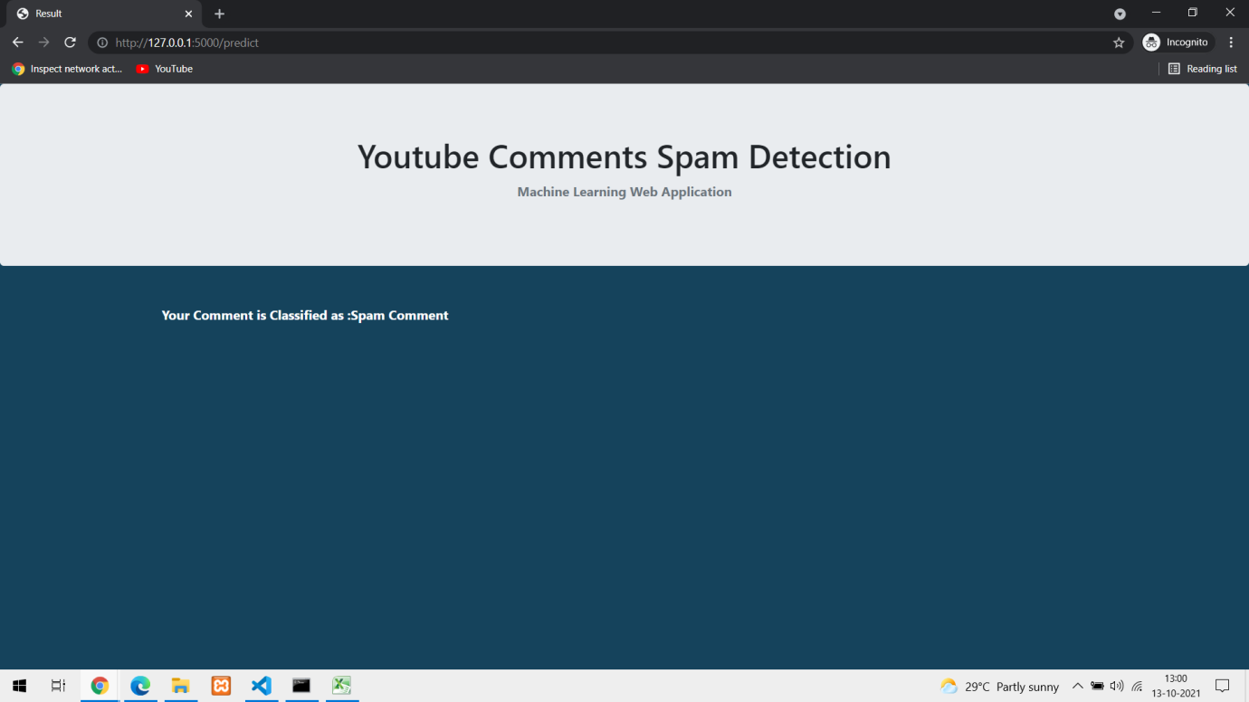

CONCLUSION For classifying the YouTube comments as spam and not spam (ham) there are various techniques used. This approach has been tested with real-time YouTube comments and given an overall outcome which is 18% more accurate than the existing approach. As YouTube API is open platform to all users, it might change the behavior of spammers over the period of time. In real world, YouTube spam feature will not be constant it keeps on changing an precipitous way.”
REFERENCES
[1] P. Chopade, J. Zhan, and M. Bikdash. Node attributes and edge structure for large-scale big data network analytics and community detection. In International Symposium on Technologies for Homeland Security (HST), pages 1–8, 2015.
[2] X. Que, F. Checconi, F. Petrini, and J. A. Gunnels. Scalable community detection with the louvain algorithm. In Parallel and Distributed Processing Symposium (IPDPS), pages 28–37, 2015.
[3] P. Cui, Z. Wang, and Z. Su. What videos are similar with you?:Learning a common attributed representation for video recommendation. In ACM International Conference on Multimedia (MM),pages 597–606, 2014.
[4] H. Lu, M. Halappanavar, A. Kalyanaraman, and S. Choudhury. Parallel heuristics for scalable community detection. In International Parallel & Distributed Processing Symposium Workshops (IPDPSW), pages 1374–1385, 2014.R. Nicole, “Title of paper with only first word capitalized,” J. Name Stand. Abbrev., in press.
[5] S. Oreg and N. Sverdlik. Source personality and persuasiveness:Big five predispositions to being persuasive and the role of message involvement. Journal of Personality, 82(3):250–264, 2014.

